IoT Management System
Software Architecture Design Document
Document ID : [IoTMS_Design_001]

2 Team
Jonghyun Han
Youk Kwon
Bohyun Jung
Dongog Min
Youngkeun Jang
Jinwook Hyun

Copyright © 2015 Team2 of CMU S/W Architecture Training Program. All Rights Reserved.

This document has been published for CMU Software Architecture Training Program by Team2. Team 2 cannot accept responsibility for any errors or omissions or for any loss occurred to any person, whether legal or natural, from acting, or refraining from action, as a result of the information contained herein. Information in this document is subject to change at any time without obligation to notify any person of such changes.

The this document cannot be used for any purpose other because this document is designed for educational purposes. Also, Team2 may have patents or patent pending applications, trademarks copyrights or other intellectual property rights covering subject matter in this document. The furnishing of this document does not give the recipient or reader any license to these patents, trademarks copyrights or other intellectual property rights.

No part of this document may be communicated, distributed, reproduced or transmitted in any form or by any means, electronic or mechanical or otherwise, for any purpose, without the prior written permission of Team2.

The document is subject to revision without further notice.

All brand names and product names mentioned in this document are trademarks or registered trademarks of their respective owners.

Document Information
Team 2,
LG Electronics,
Software Architecture Training Program,
Software Engineering Institute(SEI)
Carnegie Mellon University.

Contact us: jonghyun.han@lge.com

About This Document

Revision History
Version | Date | Comment | Author | Approval
0.1 | 2015-06-21 | Document outline | Dongog Min

Purpose
This document describes architecture of IoT Management System.

Scope
This document includes overall and sub system architecture as follows
- Description of the Project Context
- The Architectural Drivers
- The Views
- Design decisions and rationale
- Description of how the system will satisfy the QAs

Audience
This document’s audiences are as follows
- All Stakeholders
- Project Manager
- Architect
- Development Team

Related Documents
Following documents can be reference for understand this document.
Document ID | Comment
[IoTMS_TimeLog_001] | Time Log and Ear-value
[IoTMS_Interface_001] | Description Interface among components
Contents

1 Document Description 8
1.1 Purpose 8
1.1.1 Purpose and Scope 8
1.1.2 Audience 8
1.2 Document organization 8
1.3 Common notation 9
1.4 Terminology and definitions 9
1.5 References and relevant documents 9

2 Project Overview 11
2.1 Overview 11
2.2 Environment 11
2.3 Context 11
2.3.1 Market Context 11
2.3.2 Organizational Context 12
2.3.3 Business Context 12
2.3.4 Technological Context 13
2.4 Stakeholders 13
2.5 Relation with stakeholders 14

3 Architectural Drivers 15
3.1 High Level Functional Requirements 15
3.2 Use Cases 16
3.2.1 Use Cases 16
3.2.2 Use Case Scenarios 17
3.3 Constraints 22
3.3.1 Business Constraints 22
3.3.2 Technological Constraints 22
3.4 Quality Attributes 23
3.4.1 Quality Attribute Scenarios 23
3.4.2 Quality Attribute Utility 28

4 System Context 29

5 Overall Architecture Design 30
5.1 Architectural Style 30
5.1.1 Client-Server Architectural Pattern 30
5.1.2 MVC Architectural Pattern 30
5.1.3 Publish-Subscribe Pattern 31
5.2 Static Perspective 31
5.2.1 Static View of overall 31
5.2.2 Static View of 1st Decomposition 31
5.2.3 Design rational of Static Perspective 32
5.2.4 Tactics 32
5.2.5 Related Quality Attributes 32
5.3 Dynamic Perspective 32
5.3.1 Dynamic View of overall 33
5.3.2 Dynamic Behavior 33
5.3.3 Interfaces 33
5.3.4 The reason why we are use JSON 33
5.3.5 The reason why we are using Event-Bus 34
5.3.6 The reason why we are using DataBase 34
5.3.7 Tactics 34
5.3.8 Related Quality Attributes 34
5.4 Physical Perspective 34
5.4.1 Design Rationale of Physical Perspective 35
5.4.2 Develop Environment 35
5.4.3 Tactics 35
5.4.4 Related Quality Attributes 35

6 Decomposition of System Architecture Design 36
6.1 Dynamic view of Overall system 36
6.1.1 Dynamic view of overall system 36
6.1.2 Describe elements 36
6.2 Architecture design of Model 37
6.2.1 Architecture Design of NodeManager 37
6.2.2 Architecture Design of RuleManager 43
6.2.3 Architecture Design of Logger 43
6.2.4 Architecture Design of Message 44
6.3 Architecture Design of UI and UI Controller 44
6.3.1 Static Perspective 44
6.3.2 Dynamic Perspective 44
6.3.3 Design Rationale 45
6.3.4 Related quality attributes 45
6.4 Architecture Design of Communication 45
6.4.1 Static Perspective 45
6.4.2 Dynamic Perspective 45
6.4.3 Design Rationale 45
6.4.4 Related quality attributes 45
6.5 Architecture Design of SA-Node 45
6.5.1 Static Perspective 45
6.5.2 Dynamic Perspective 46
6.5.3 Design Rationale 46
6.5.4 Related quality attributes 46
6.6 Security 46
6.6.1 Secure communicate between User and User Interface 46
6.6.2 Secure communicate between IoTMS and SA-Node 46

7 Document Dictionary 50
7.1 Glossary 50
7.2 Acronyms 50
7.3 Index 50

Document Description

Purpose

Purpose and Scope
This document describes architecture of IoT Management System. Team2 (hereinafter Team2) was prepared this document for the Studio Project of the CMU Software Architecture Training Program. The purpose of this document is communication with stakeholders, and this document contains the following scope.
Scope
This document includes overall and sub system architecture as follows
- Description of the Project Context
- The Architectural Drivers
- The Views
- Design decisions and rationale
- Description of how the system will satisfy the QAs

Audience
This document was published for audiences are as follows
- All Stakeholders
- Project Manager
- Architect
- Development Team

Document organization
This document is organized as follows
Section | Description
Document Description | Describe overall of this document which includes Purpose, Notation, Terminology, Definitions and References.
Project Overview | Describe the project, purpose and scope. Also, Describe business, organizational, mission, or marketing concerns that are relevant to the project.
Architectural Drivers | Describe the architectural drivers for the system. The architectural drivers contains high level functional requirements, technical constrains, business constrains and quality attributes.
System Context | Describe context drawing of the system represents scope of the system, relationship to external entities.
Overall Architecture Design | Describe overall system architecture design in each perspectives which are static, dynamic and allocation. Also, Describe design decisions, rationale and how system to satisfy QAs.
Decomposition of System Design | Describe in-depth system architecture design in each perspectives which are static, dynamic and allocation. And describe communication I/F among each components. Also, Describe design decisions, rationale and how system to satisfy QAs.
Document Dictionary | Describe index, glossary, and acronym list.

Common notation
To do determine

Terminology and definitions
Terminology and definitions in this document are described.
Terminology | Description
IoT | Internet of Things
IoTMS | Internet of Things Management System
JSON | JavaScript Object Notation
JDBC | Java DataBase Connectivity
SQL | Structured Query Language
RSA | Rivest Shamir Adleman. The crypto algorithm based on Public-key
AES | Advanced Encryption Standard. The crypto algorithm based on Symmetric-key
EventBus | EventBus allows publish-subscribe-style communication between components without requiring the components to explicitly register with one another (ref. Google’s explain)
Guava | Google’s project. We are using this Library for EventBus
RM | RuleManager.
NM | Node Manager manage nodes. Node Manager add and remove node when new node is added or removed by User.
CM | Communication Manager
Link

References and relevant documents
Following documents can be reference for understand this document.
Document ID | Comment
[IoTMS_TimeLog_001] | Time Log and Ear-value
[IoTMS_Interface_001] | Description Interface among components
[IoTMS_WebAPI_001]
[IoTMS_TestCase_001]

Project Overview

Overview
Our Team is working for an organization that intends to enter the IoT market.
We make an Internet of Things(IoT) system that enables end-users to communicate with sensors and actuators installed in the home or business via PC or smartphone connected to the internet. (For example, indoor and outdoor light, temp and humidity sensor, door open-close actuator, door open-close sensor, secure alarm, presence/proximity sensor)

Environment
The home or business uses the internet with standard Wi-Fi router.
Sensors / actuators can connect to the home or business network with Arduino microcontroller enabled Wi-Fi.
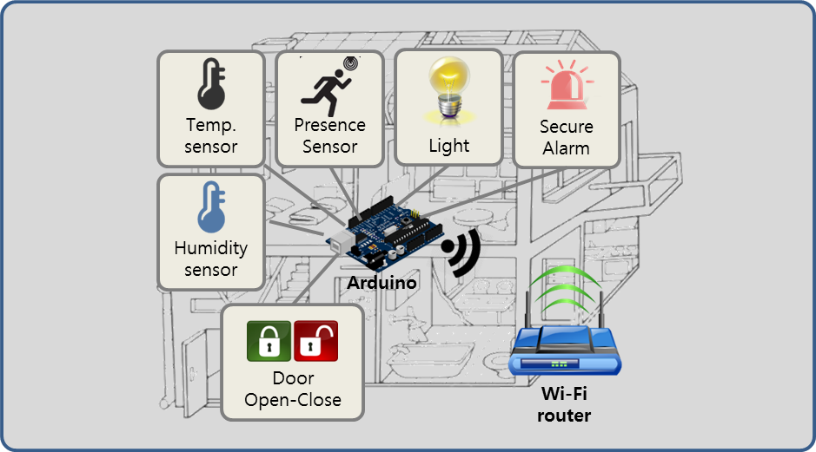
Figure 1. Environment of project

Context

Market Context
Market Context
Stakeholders | Customer, End-user, System Installer, Developer
System Access | Users want to access the system via PC, Mobile devices
Functional  expectations | After system installation, users expect the system to work  automatically by assigned rules of sensors and actuators
Environment | There are many vendors developing a system, sensors and actuators. But there is no standard of interface.
Table 1. Market Context

Organizational Context
Organizational Context
Roles and  responsibilities | Project Manager(includes planning, risk and configuration, schedule)  Architect  Requirement Manager  Test Manager  Documentation Manager  Developer (all members)
Technical  background | Digital-Appliance SW solution researcher & developer  Smart-phone SW developer  Camera module testing SW developer
Table 2. Organizational Context

Business Context
Business Context
Date of Delivery | 26 June 2015
Time Resources | 498 man-hours (48+450)  :48 man-hours (8 hours X 6 people) in Korea  :450 man-hours(3 hours X 6 people X 5 days X 5 weeks) in CMU
Strategy | Easy to use & high extensibility for sensors/actuators
Target Market | B2B - Building Architect Office, B2C - DIY User
Profit Model | Rental Service, Standalone, System Education, Maintenance
Future direction | Many kinds of sensors/actuators(indoor air quality sensor, camera, thermostat controller and so forth) is used & it makes a lot of use case. So big-data of these cases would enable to make services of IoT System.
Table 3. Business Context

Technological Context
Technical Context
Development  Skills | Java , C, JavaScript, HTML5
Platforms | Arduino Platform, Laptop Computers
Tools | Eclipse, Arduino IDE
OS | Windows, Linux
HW platform | Arduino , X86
Table 4. Technical Context

Stakeholders
Stakeholders of the IoTMS are follows
- Customer
- End-User
- System Installer
- Application Developer
- Hardware Developer
- Value-added-resellers (VARs)
- Service Provider
- Maintainer
- Project consultant (like mentor)

Relation with stakeholders
Below diagram is relation among key stakeholders and the IoTMS.
- 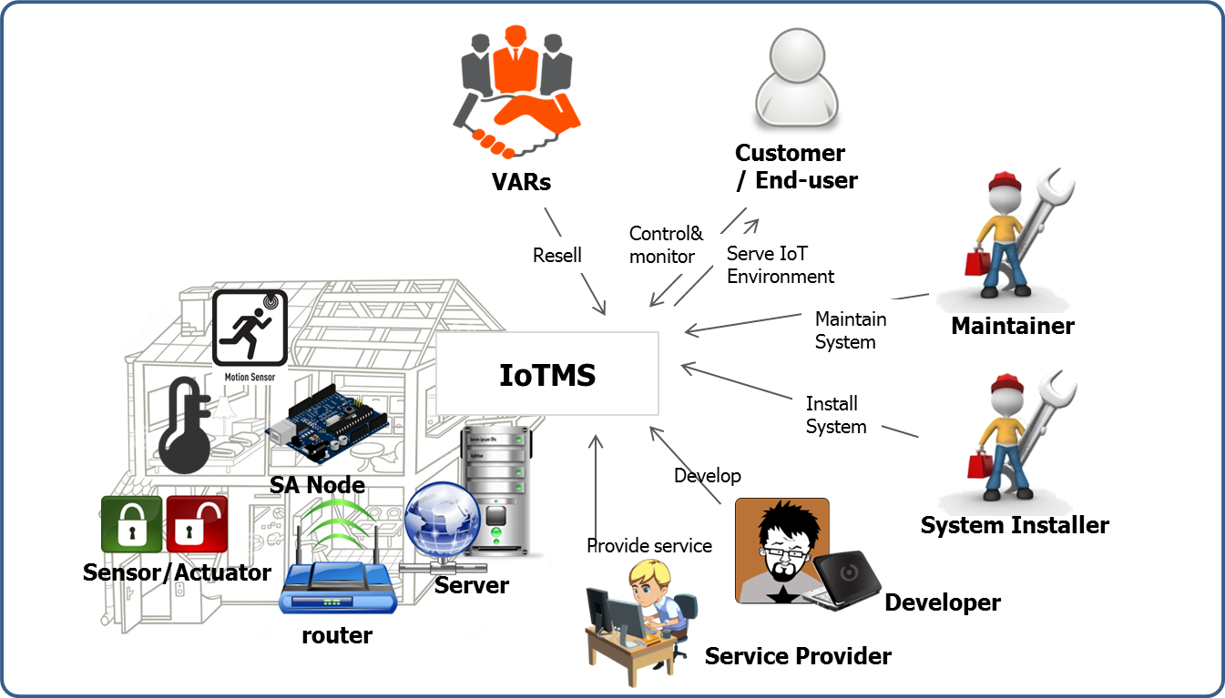
Figure 2. Relation with stakeholders

Architectural Drivers
In this section, this document describes high level function requirements extracted from project description document. And then, it describes use case scenario and use case diagram extracted from high level function requirement. Also, this document is explaining constraints and quality attribute.

High Level Functional Requirements
The high level functional requirements from project description document are as follows.
Req. ID | Description
FR-01 | The system provides a secure service (e.g. authentication, authorization, accounting) that allows users to query the home to find out how many nodes are installed and what sensors/actuators are installed on each node.
FR-02 | The system provides a secure service that allows users to determine the temperature/humidity, turn on and off lights, open and close the door, turn on the alarm, and determine if anyone is home.
FR-03 | The system should store sensor values and log all user commands for some period of time (e g. a configurable sliding window of data with 72 hours as the default value, minimum 8 hours) and allow user applications to review their sensor and command history in a secure and private way.
FR-04 | The system should not allow unauthorized persons to access the home sensors/actuators, or access any data generated by them, or any data stored in the system.
FR-05 | The system should not allow unauthorized persons to register a sensor that they do not own
FR-06 | The system should send an emergency message when the door is manually opened while alarmed or the house is suddenly occupied while alarmed.
FR-07 | The system should not allow automatic door opening while the house is alarmed. The alarm must be disabled prior to opening the door.
FR-08 | The system should send a message to the user to inform them when the house is vacant and not alarmed. It should ask them if they want to alarm the home. If they do not respond within 5 minutes (configurable, 5 minutes is the default value - feel free to shorten this to a few seconds for test and demonstration purposes) the house will lock itself. If a door is open, it will automatically close the door before alarming the house.
FR-09 | The system should automatically turn off the lights when no one is home and 10 minutes elapses (configurable, 5 minutes is the default value - feel free to shorten this to a few seconds for test and demonstration purposes).
FR-10 | It should be easy for users to add and remove nodes to and from the system without having to restart the system or other nodes (you will have to demonstrate this). This includes secure registration and recognition of the type of sensors and actuators provided by the node.
FR-11 | The system should make it easy for application developers (private persons, VARs, or other 3rd parties) to build custom apps, services, and/or make mashups from existing available services (you should describe how the design supports this).
FR-12 | The system should make it easy for developers to implement new protocol about new devices.
FR-13 | The system provides user define scenario service like IFTTT(IF This Then That)
FR-14 | When the system sends emergency message, it will be E-mail. In future, it can be SMS or tweet.
FR-15 | When sensors value is abnormal(out of range), the system sends an alarm message to user.
FR-16 | User sets configurations of E-mail address, logging-duration, secure response time and lights waiting time.
FR-17 | The system provides Web APIs for Web developer.
Table 5. High level function requirement

Use Case Scenarios
Describe use case scenarios and diagrams are as follows.

UC-01: Query nodes and sensor/actuators

Use Case Title : Query nodes and sensor/actuators | Use Case ID : UC-01
General use case description:
This use case describes how to query nodes and sensors/actuators on each node information by user in a secure way
Entities involved:
User / IoT Management System(IoTMS)
Preconditions
User has registered in IoTMS using register menu
Primary use case flow of events:
1. User logs in IoTMS using by user’s ID and Password
2. IoTMS allows user to access System
3-1. User queries nodes information to IoTMS
A. IoTMS returns number of nodes to User.
B. User selects a node which user wants to know detailed information.
C . IoTMS returns sensors/actuators information in the node to User.
D. repeat B-C until user ends detailed query
3-2. User queries whole nodes information to IoTMS
A. IoTMS makes list of nodes and sensor/actuators within node
B. IoTMS returns list to User.
4. User logs out from IoTMS .
Primary use case post-conditions:
User querying is completed
Alternate use case #3-1
1. It is possible to query malfunction nodes and sensors/actuators each node.
Table 6. UC-01 Query nodes and sensor/actuators

Use case diagram
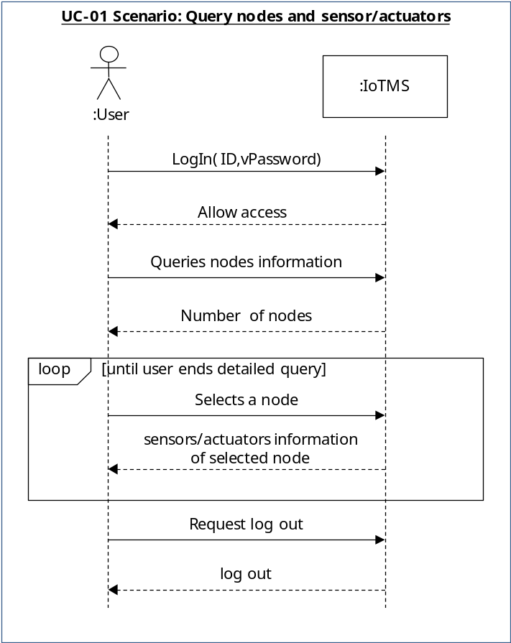

UC-02: Add new rule

Use Case Title : Add new rule | Use Case ID : UC-02
General use case description:
This use case describes how the system reacts by conditions previously defined
Entities involved:
IoT Management System(IoTMS)
Preconditions
User has logged in IoTMS .
IoTMS manages the list of predefined rule sets.
Primary use case flow of events:
1. User adds a new rule with conditions and actions to IoTMS.
2. Check whether the condition is unique and no collision with registered conditions.
3. If no issue on the condition, IoTMS accepts and applies the rule to predefined rule set.
4. IoTMS displays added rule set to User.
Primary use case post-conditions:
It is completed that new rule is inserted into predefined rules set.
Alternate use case #3-1
3.1. If the given condition is already existing or collision with other rules, IoTMS invokes error message with the reason.
Table 7. UC-02 Add new rule

Use case diagram
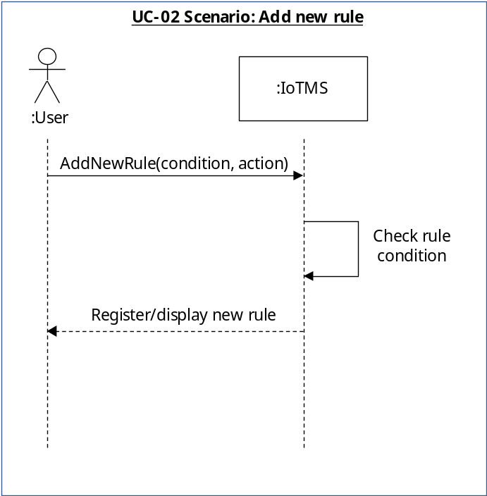

UC-03: Review histories of sensors/actuators state and user commands

Use Case Title : Review histories of sensors/actuators state and user commands | Use Case ID : UC-03
General use case description:
This use case describes how to review user’s sensor and command history by user in a secure way
Entities involved:
User
IoT Management System(IoTMS)
Preconditions
User has registered in IoTMS using register menu
Primary use case flow of events:
1. User tries to log in IoTMS using by user’s ID and Password
2. IoTMS allows user to access System
3. User requests sensors or commands history to IoTMS
4. IoTMS checks that user has permission
5. IoTMS asks period of history what user want to review to user
6. User sends period what user want to review
7. IoTMS makes list of history what user want
8. IoTMS displays list of sensors and commands history to user
Primary use case post-conditions:
User Reviewing history is completed
Alternate use case #5-1
5.1. If User cannot login because of incorrect ID/password, IoTMS displays “Find Password” or “Find User-ID” for User
Table 8. UC-03 Review histories of sensors/actuators state and user commands

Use case diagram
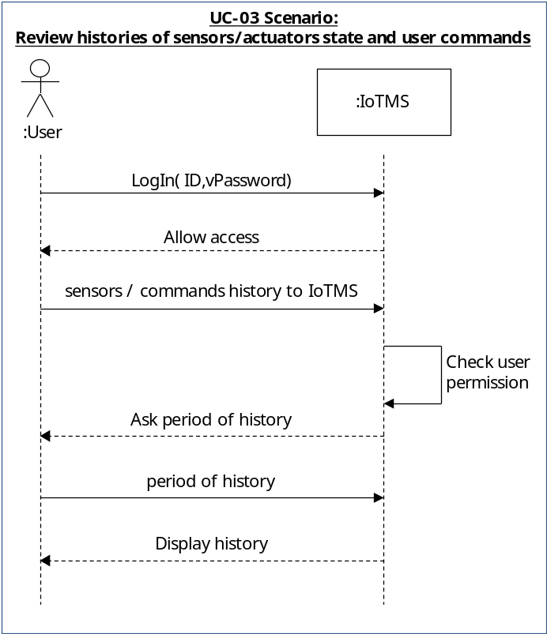

UC-04: Test control/monitor

Use Case Title : Test control/monitor | Use Case ID : UC-04
General use case description:
This use case describes how to test control/monitor sensors/actuators after log-in
Entities involved:
Secure service
Preconditions
User has already logged in IoT Management System(IoTMS).
Primary use case flow of events:
1. User tries to log in IoTMS using by user’s ID and Password
2. User monitors the temperature/humidity.
3. User turns on indoor light.
4. User turns on outdoor light.
5. User turns off indoor light.
6. User turns off outdoor light.
7. User controls door close.
8. User controls door open.
9. User monitors door sensors.
10. User monitors presence/proximity sensor.
Primary use case post-conditions:
User logs out to finish access the server.
Alternate use case #1-1
1.1 If user inputs wrong ID or password, system informs log-in fail.
Table 9. Test control/monitor

Use case diagram
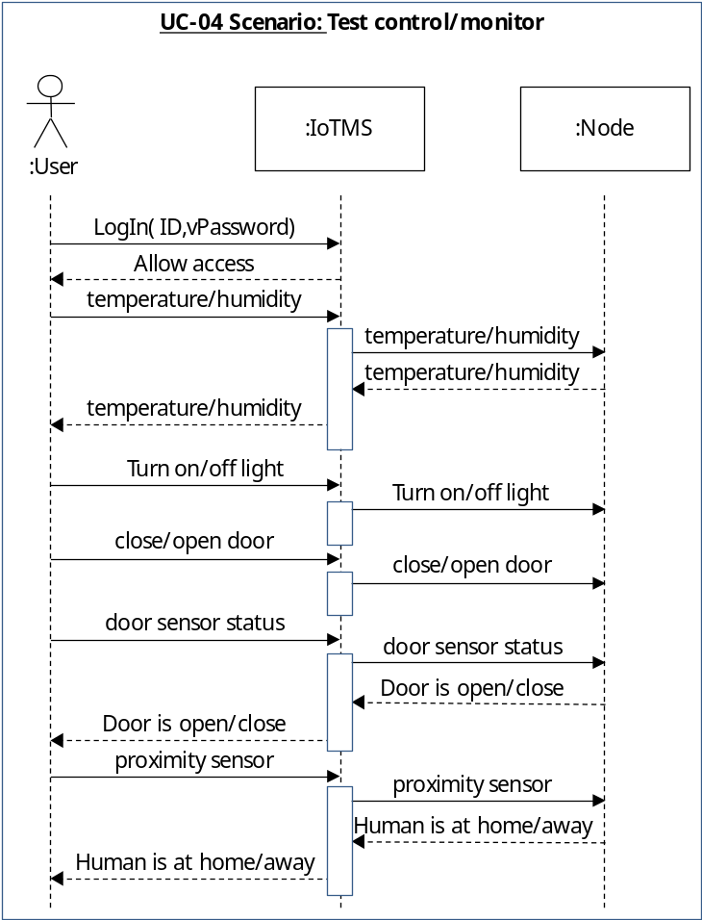

UC-05: Register node

Use Case Title : Register node | Use Case ID : UC-05
General use case description:
Server register node.
Entities involved:
Installer, User(Customer), Server, Node
Preconditions
IoTMS and node have same serial key.
Primary use case flow of events:
1. User log in IoTMS using user’s ID and Password
2. Installer or user requests to discover the node to server.
3. IoTMS discovers the node.
4. IoTMS displays the node that can be registered.
5. Installer or user inputs the serial key and confirms to register node.
6. IoTMS registers the node with serial key.
Primary use case post-conditions:
Server and node can communicate with each other.
Alternate use case
3.1 if there is no node, display nothing.
3.2 if there is registered node, indicates that registered nodes
Table 10. Register node

Use case diagram
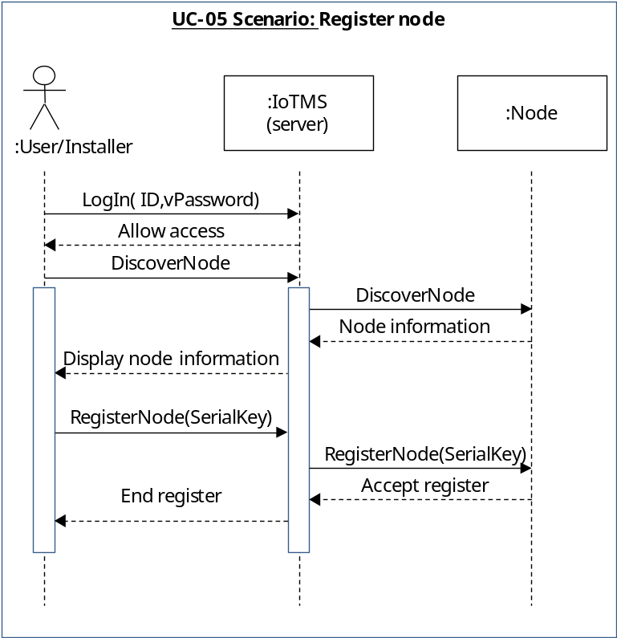
Constraints

Business Constraints
Following table describes business constraints.
ID | Description
B_CST-01 | Schedule Limitation: 7 weeks(include a plan-time in Korea)  498 man-hours (48+450)  :48 man-hours (8 hours X 6 people) in Korea  :450 man-hours(3 hours X 6 people X 5 days X 5 weeks) in CMU
B_CST-02 | Human Resources: 6 people
B_CST-03 | User can’t buy SA nodes and sensors/actuators separately.
Table 11. Business Constraints

Technological Constraints
Following table describes technical constraints.
ID | Description
T_CST-01 | End-user communicates with sensors/actuators via PC or Smartphone connected to the Internet.
T_CST-02 | An SA node has 1 or more sensors/actuators.
T_CST-03 | An SA node uses Wi-Fi communication(802.11)
T_CST-04 | The IoTMS should be made by Java Language & Arduino device
T_CST-05 | The IoTMS works on PC or Server
Table 12. Technological Constraints

Quality Attributes

In this section, describe quality attributes and quality attribute scenarios.
The quality attributes of this project are as follows.
ID | QA Type | Description
QA-01 | Availability | Server recognizes malfunction of sensors within 10 seconds.
QA-02 | Usability | All function of System is served in 3 depth UI.
QA-03 | Scalability | IoT Management System is limited to 50 SA Nodes.
QA-04 | Modifiability | Emerging new protocol, it is possible to be developed in 2 man-months.
QA-05 | Security | IoT Management System allow only authorized user to access in secure way.
QA-06 | Testability | 80% of test cases can be tested within 1 day.
QA-07 | Performance | The response time of controlling and monitoring is within 10 seconds.
QA-08 | Availability | Detect and notify Logging failure in 30 seconds.
Table 13. Quality attributes

Quality Attribute Scenarios
Followings are quality attribute scenarios represented by six-part scenario. These quality attributes must be considered when designing system architecture.

QA-01: Sensors availability

Scenario Title:  Availability | Scenario ID: QA-01
Raw Quality Attribute  Description: | Sensors availability
Source of Stimulus: | Sensors
Stimulus: | Sensor failure , sensor malfunction
Environmental Condition | Normal operation ,  The IoTMS has been installed and it works.
System Element: | • Sensors  • IoTMS
System Response: | If a sensor value is not between normal range, the IoTMS recognizes malfunction or fault of sensors. And then the IoTMS sends alarm message to user. (The normal values ranges are configured according to sensor datasheet.)
Significant Measures: | The IoTMS sends alarm message to user in 10 seconds after recognizing malfunction or fault of sensors in 3 times consecutively.
Table 14. QA-01 Sensors availability

QA-02: UI(User Interface) Usability

Scenario Title:  Usability | Scenario ID: QA-02
Raw Quality Attribute  Description: | UI(User Interface) Usability
Source of Stimulus: | User
Stimulus: | User tries to use IoTMS.
Environmental Condition | User configuration time  IoTMS run time  The user has logged into the IoTMS.
System Element: | UI of IoTMS
System Response: | When the user wants to change the settings of IoTMS or to get sensor value or to set actuator, the usage of UI should not be complicated.
Significant Measures: | UI depth is less than 3.
Table 15. UI(User Interface) Usability

QA-03: SA Nodes Scalability

Scenario Title:  Scalability | Scenario ID: QA-03
Raw Quality Attribute  Description: | SA Nodes Scalability
Source of Stimulus: | User( Installer, DIY user ..etc. )
Stimulus: | Add another SA Nodes
Environmental Condition | IoTMS has one SA node.
System Element: | IoTMS , SA node
System Response: | When the user wants to add two or more SA node to their own IoTMS,  1. Install additional SA node at the home.  2. IoTMS find & connect additional SA Node on network.  3. complete.
Significant Measures: | IoTMS allow up to 50 SA Nodes.
Table 16. SA Nodes Scalability

QA-04: Communication protocol Modifiability

Scenario Title:  Modifiability | Scenario ID: QA-04
Raw Quality Attribute  Description: | communication protocol Modifiability
Source of Stimulus: | developer , 3rd party vendor , …etc
Stimulus: | new communication protocol between IoTMS and SA node
Environmental Condition | Current IoTMS communicate with SA node using WiFi only.  New communication moldule’s compile time , build time
System Element: | Communication manager of IoTMS
System Response: | Emerging new protocol, SW developer make/test/deploy new communication protocol module.
Significant Measures: | Emerging new protocol, it is possible to be developed in 2 man-months.
Table 17. Communication protocol Modifiability

QA-05: User access Security

Scenario Title:  Security | Scenario ID: QA-05
Raw Quality Attribute  Description: | User access Security
Source of Stimulus: | unauthorized user
Stimulus: | unauthorized user tries to access IoTMS
Environmental Condition | IoTMS is online.  IoTMS has a list of authorized users.
System Element: | IoTMS
System Response: | If the user is not in the list and tries to access to IoTMS , IoTMS dosen't allow login.
Significant Measures: | IoTMS never allow unauthorized user to access.
Table 18. User access Security

QA-06: SW module Testability

Scenario Title:  Testability | Scenario ID: QA-06
Raw Quality Attribute  Description: | SW module Testability
Source of Stimulus: | Test engineer , Test manager.
Stimulus: | SW module Test
Environmental Condition | SW module development time  SW module integration time  SW module deployment time  SW module run time
System Element: | SW module of IoTMS  SA node
System Response: | Test engineer test the quality of the software based on the test case , capture the results , feedback to the developers.
Significant Measures: | The 80% of test cases can be tested within 1 day.
Table 19. SW module Testability

QA-07: IoTMS-SA node Response time Performance

Scenario Title:  Performance | Scenario ID: QA-07
Raw Quality Attribute  Description: | IoTMS-SA node Response time Performance
Source of Stimulus: | User
Stimulus: | User's direct request to SA node.
Environmental Condition | normal operation mode of IoTMS
System Element: | IoTMS  SA node
System Response: | When the user request to get sensor value,  1. IoTMS send the "get sensor value" message to SA node .  2. SA node measure sensor value.  3. SA node send "sensor value" message to IoTMS.  4. IoTMS display "sensor value".  When the user request to set actuator status,  5. IoTMS send the "set actuator status" message to SA node.  6. SA node set actuator.  7. SA node send "complete actuator control" message.  8. IoTMS display "actuator status".
Significant Measures: | The response time of controlling(System Response 5~8) and monitoring(System Response 1~4) SA node is within 10 seconds.
Table 20. IoTMS-SA node Response time Performance

QA-08: Logging history availability

Scenario Title:  Availability | Scenario ID: QA-08
Raw Quality Attribute  Description: | Logging history availability
Source of Stimulus: | Disk space
Stimulus: | The logging module fails to work when the disk space is full .
Environmental Condition | Normal operation :  Logging module is logging history to Disk .
System Element: | Log Manager (SW)  Disk (HW)
System Response: | IoTMS detect and notify Disk Full to administrator
Significant Measures: | Detect and notify Logging failure in 30 seconds by IoTMS
Table 21. Logging history availability

Quality Attribute Utility

Quality Attribute Utility Tree

QA Type | ID | Description | Priority | Difficulty
Availability | QA-01 | Server recognizes malfunction of sensors within 10 seconds. | High | Medium
Availability | QA-08 | Detect and notify Logging failure in 30 seconds. | Low | Low
Usability | QA-02 | All function of System is served in 3 depth UI. | Low | Medium
Scalability | QA-03 | IoTMS allow up to 50 SA Nodes. | High | High
Modifiability | QA-04 | Emerging new protocol, it is possible to be developed in 2 man-months. | Medium | Medium
Security | QA-05 | IoTMS allow only authorized user to access in secure way. | High | Medium
Testability | QA-06 | 80% of test cases can be tested within 1 day. | Medium | Medium
Performance | QA-07 | The response time of controlling and monitoring is within 10 seconds. | Low | High

Most priority Quality Attributes

ID | QA Type | Description | Priority | Difficulty
QA-01 | Availability | Server recognizes malfunction of sensors within 10 seconds. | High | Medium
QA-03 | Scalability | IoTMS allow up to 50 SA Nodes. | High | High
QA-05 | Security | IoTMS allow only authorized user to access in secure way. | High | Medium

System Context
The System context diagram describes interaction among User, Node and IoTMS.
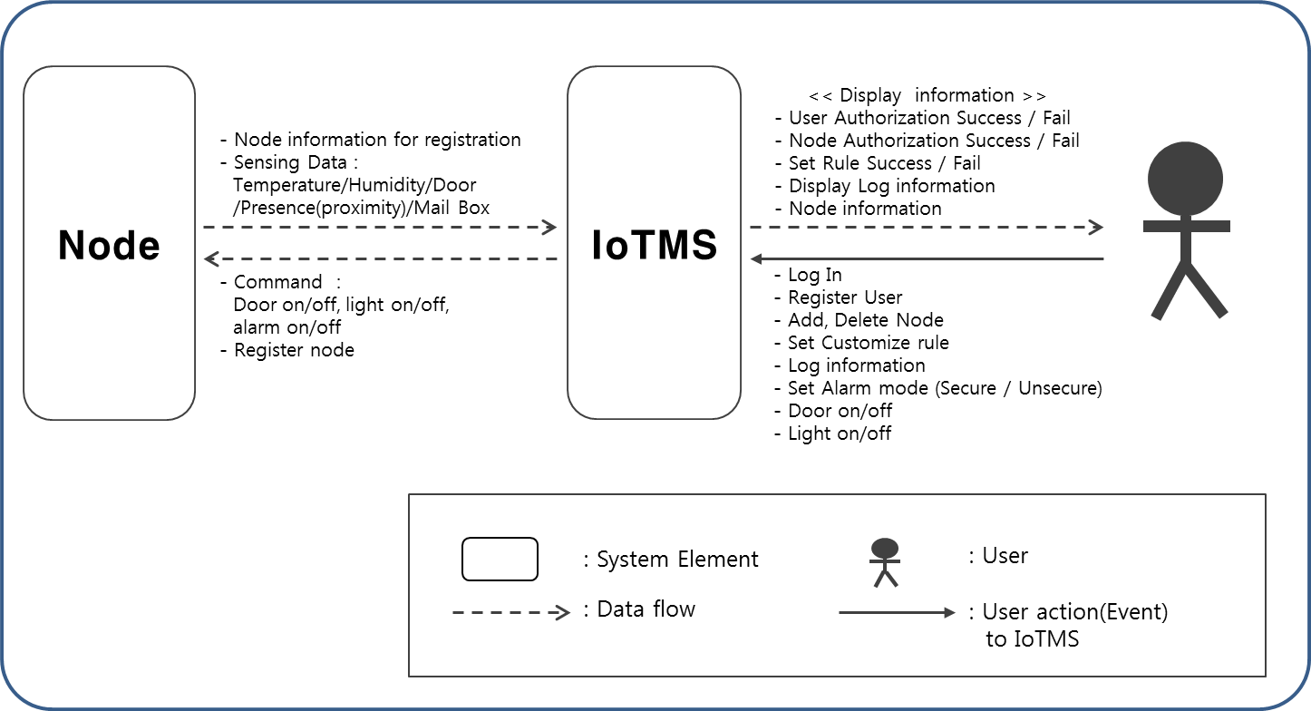
Figure 3. System Context Diagram

User are using IoTMS for adding/removing node, controlling actuators or sensors(e.g. Door open), setting alarm mode and so forth. Also, User can monitor sensor’s status via Internet. User should be required log-in to the IoTMS system when user want to see sensor’s status or control sensors or actuators.
Below describes each elements of system context diagram.

Element | Description
User | 실제 시스템을 사용하는 사용자이고, 로그인을 통해서 사용해야되고 어쩌구저쩌구
IoTMS | 전체 시스템이고, Node와 연결되어 있고, 사용자를 위해서 Interface를 제공하고, 블라블라
Node | SA-Node. 아두이노로 구성되어있고, 센서가 6개 달려있는데, 이중에 actuator는 뭐고..블라블라
Table 22. Describe elements of System Context Diagram

Overall Architecture Design
In this section, we describes overall system architecture and important architecture design decision with the reason.

Architectural Style
In this section, we describes architecture style of overall system and architecture

Client-Server Architectural Pattern
IoTMS is working like server for managing a number of nodes. Nodes are working like client and they connect IoTMS easily for scalability.
We applied Client-Server Style because IoTMS and SA nodes are physically separated.

Promoted  Quality Attributes | Description
Scalability | It is easy to scalable because the several different nodes works with the same behavior.
Modifiability | There’s no coupling between server and client. Therefore, both sides can be developed independently if they share the same protocol.

Inhibited  Quality Attributes | Description
Security | Data can be hijacked by malicious attacker. For enhancing the security, IoTMS provides options for application layer level security. With the basic security option is enabled, data will be encrypted with one time session key based on AES_128. One time session key will be shared with public key cryptography based on RSA_512. Section 6. will explain something more about this.
Performance | Number of SA nodes supported at the same time is up to 50. Based on the experiment, the performance degrade is not observed.
Availability | Single pointer of failure. For detecting the problem occurred on IoTMS, IoTMS support emergency message function.

MVC Architectural Pattern
We applied MVC pattern because

Promoted  Quality Attributes | Description
Scalability

Inhibited  Quality Attributes | Description
Reliability

Publish-Subscribe Pattern
We send messages to each other via the Event bus(Publish-Subscribe Pattern) module to enhance decoupling between the major modules of IoTMS.
Promoted  Quality Attributes | Description
Flexibility | The SW defect is easily modified for each module because each module will have been decoupling in Event bus.
Testability | It is easy to test each module because each module will have been decoupling in Event bus.
maintainability | The SW debugging is easier for each module because each module will have been decoupling in Event bus.

Inhibited  Quality Attributes | Description
Performance | The Publisher of event bus broadcast all subscriber. So each subscriber should filter unwanted messages to itself. However, if many SA Nodes are added to IoTMS and the message sent from the node increases , the overall message throughput is reduced.

Static Perspective
In this section, we describe static view of overall system.

Static View of overall
우선 IoTMS의 전체 시스템 Package에 대한 Coarse-grained Decomposition style Module view of Static Perspective를 살펴보겠다.

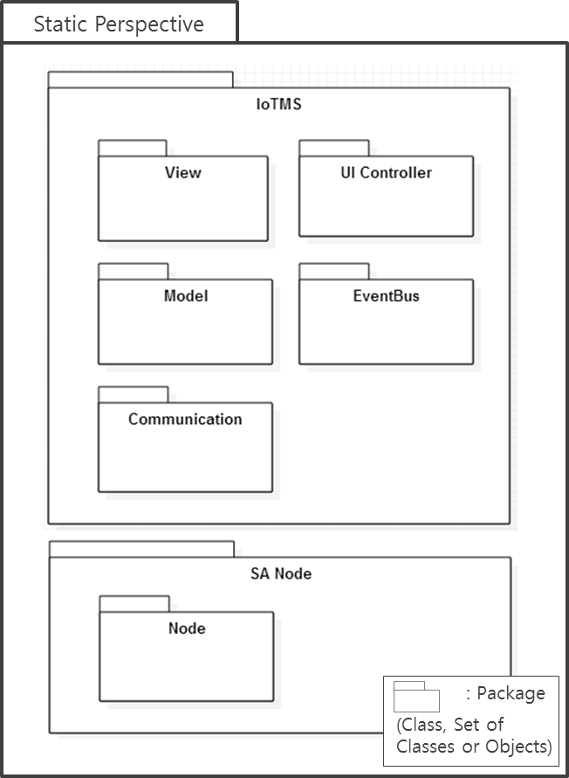
Figure 4. Module View of Overall

전체 시스템은 IoTMS와 SA Node로 구분된다.
SA Node와 IoTMS는 물리적으로 떨어져 있으며, Client-Server Style로 연결되어 있다. Node는 IoTMS의 Communication과 통신을 하여 정보를 주고받고 명령을 수행한다.
IoTMS는 View, UI Controller, Model, EventBus, Communication의 Package들고 구성되어 있다. 각 Package들에 대한 자세한 내용은 아래와 같다.

Package | Description
View | 사용자에게 보여주는 User Interface 부분을 담당한다.
UI Controller | User Managing하고, Model과 연동하는 등의 역할을 담당한다.
Model | Node, Rule에 대한 관리 및 Logging, Message 전송등의 역할을 담당한다.
EventBus | 각 Package들간의 통신의 통로를 담당한다.
Communication | SA Node의 Discover, 등록, 명령어 전송 등 SA Node와의 통신을 담당한다.

각 Package들에 대한 자세한 설명과 Design은 Section 6에서 살펴보겠다.

Static View of 1st Decomposition
위에서 살펴본 전체 Static View를 1st Decomposition하였다. 간단한 부분에 대해서는 1st Decomposition of Module View에서 2nd Decomposition을 포함하는 것도 있다. 다음은 각 Package들에 대한 Decomposition들이다.

1st Decomposition of Model

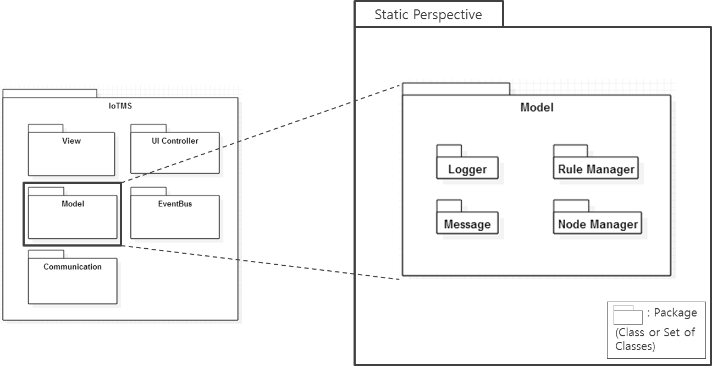
Figure 5. 1st Decomposition of Model

1st Decomposition of Communication

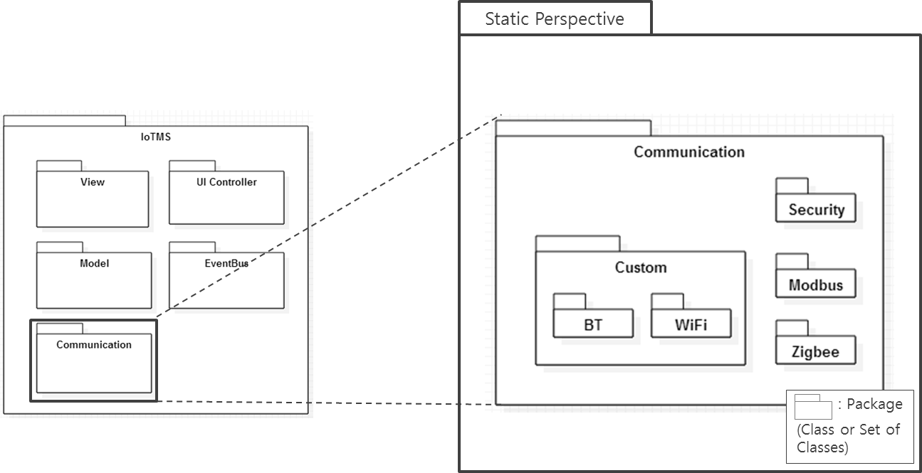
Figure 6. 1st Decomposition of Communication

1st Decomposition of View

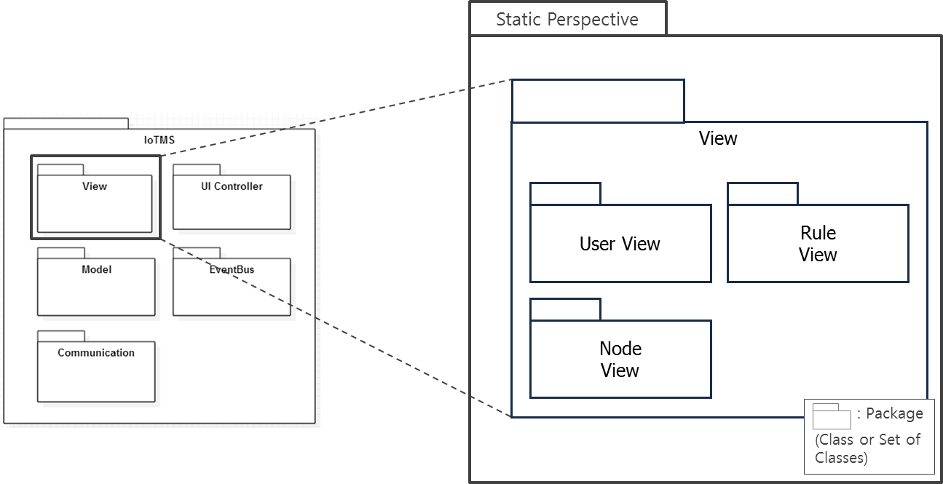
Figure 7. 1st Decomposition of View

1st Decomposition of UI Controller

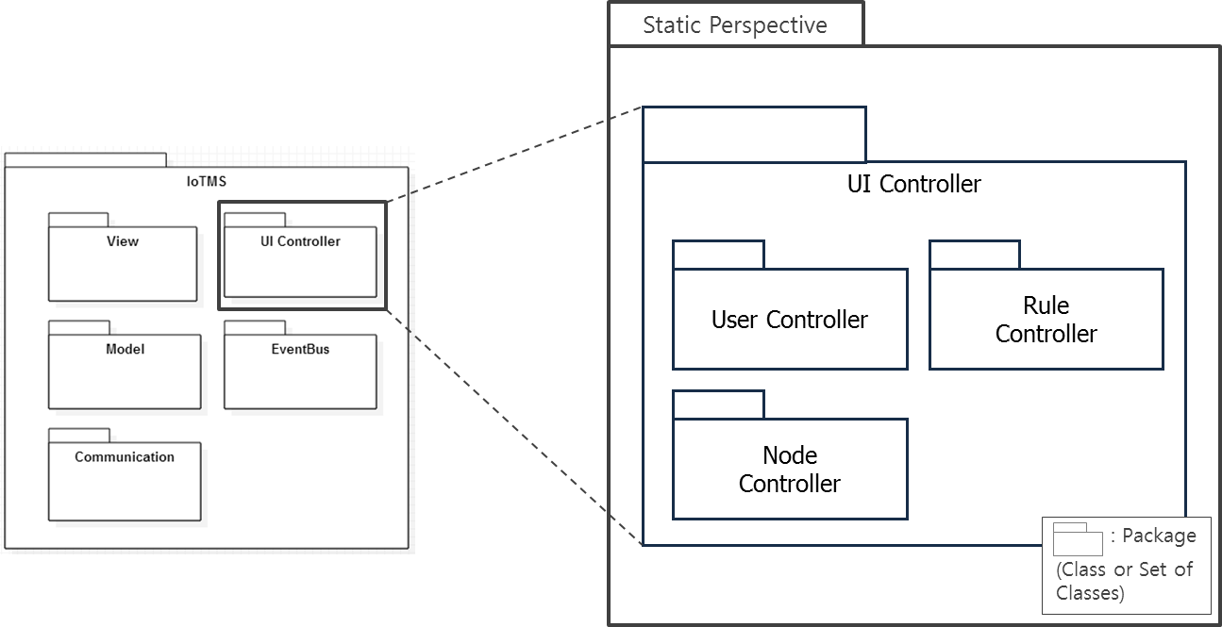
Figure 8. 1st Decomposition of UI Controller

Design rational of Static Perspective

Rationale for adopting “Client-Server” Architectural pattern

Rationale for adopting “MVC” Architectural pattern

Tactics
있으면 쓰고~

Related Quality Attributes

Dynamic Perspective

Dynamic View of overall

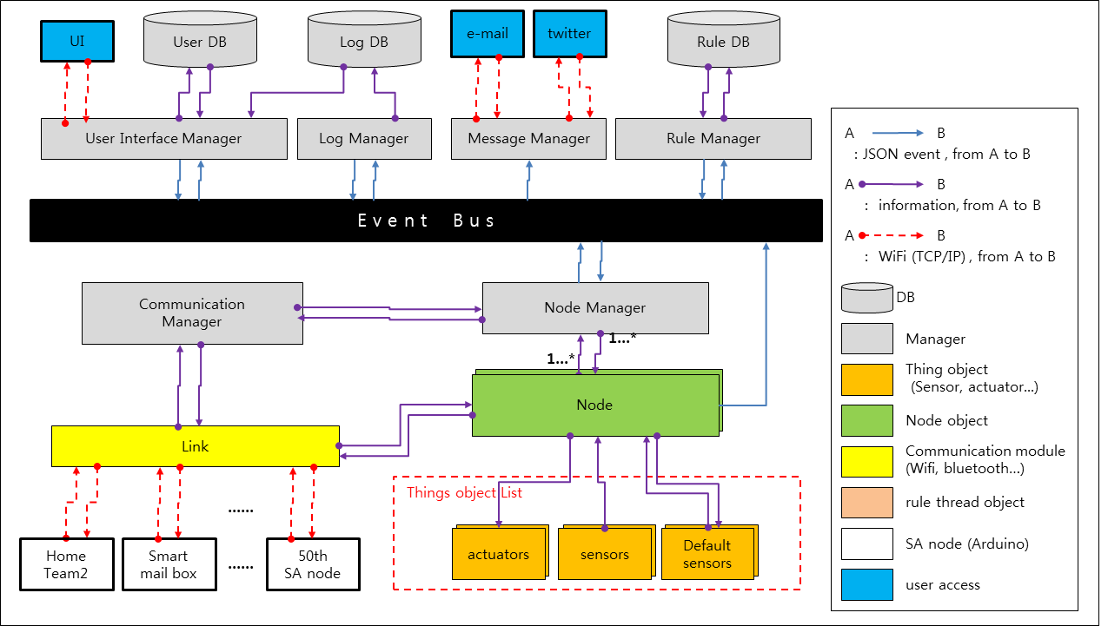
Figure 9. Dynamic view of overall system

각 Component들은 다음의 Responsibility를 갖는다.
Component | Responsibility
UI
Rule Manager
Node Manager
Communication Manager

Dynamic Behavior

Interfaces
Interface만 나와있는 약식 다이어그램. 프로토콜 정의문서

The reason why we are use JSON

- There’s no converting or reformatting for interpreting data
Overhead (5 times) for packet size is tolerable based on the experiment.
Java script which is used for UI friendly
- 3rd party developers
3rd party app and mash service developer: Used for RESTful APIs directly
Easy to publish the protocol and internal message formatting
Easy to expand a new protocol
- Database friendly
- Less coupling among packages
- Human readable and applicable to design concept directly
  - Easy to develop
  - Easy to debug
  - Less secure

The reason why we are using Event-Bus

- Less coupling among packages
Failure of any single package doesn’t affect the whole system
Each packages can be developed independently
- Easy to track the interaction between packages
Easy to debug
- Provides extensibility
Easy to add new nodes
Easy to add new feature such as message package and something like that
- Single point of failure
Event bus should be easily recoverable
- Traffic
50 simultaneous connection is tolerable based on the experiment.

The reason why we are using DataBase

Tactics
있으면 쓰고~

Related Quality Attributes

Physical Perspective

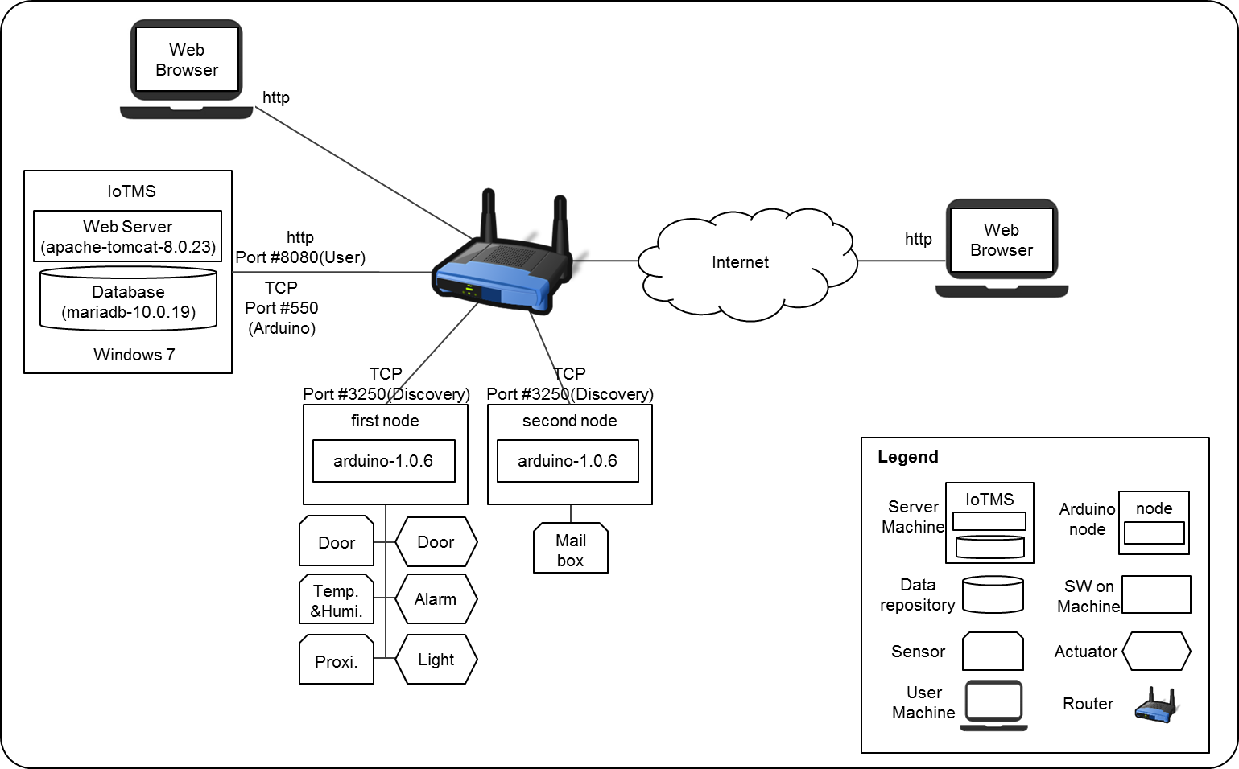
Figure 10. Allocation view of overall system

Design Rationale of Physical Perspective

The reason why we are using web server
웹 서버는 왜 썼고, 톰캣은 왜 썼나?

The reason why we are using Maria DataBase
왜 마리아 DB를 썼나용?

Develop Environment
개발환경은 어쩌구~

Tactics
있으면 쓰고~

Related Quality Attributes

Decomposition of System Architecture Design
In this section, we describe decomposition of system architecture design on each views.

Dynamic view of Overall system

Dynamic view of overall system

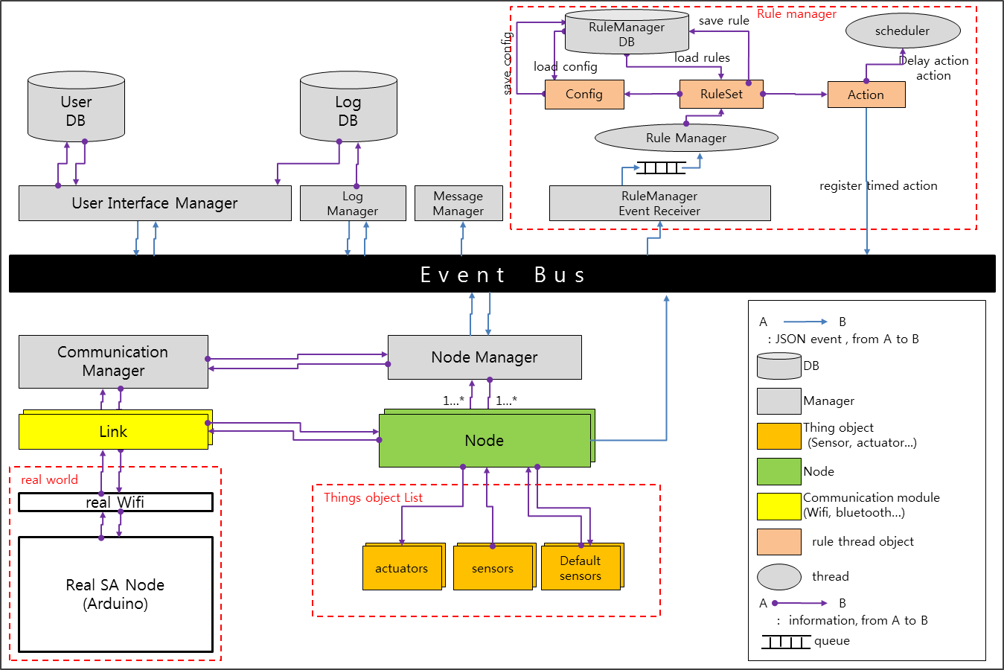
Figure 11. Dynamic view of Overrall system

Describe elements
Element | Description
Table 23. Description of each elements

Architecture design of Model
이 장에서는 Model의 Architecture Design에 대해서 기술한다. Model includes NodeManger, RuleManager, Logger, Message. 이들의 Role 및 Responsibility는 각각의 Sub-section에서 설명하도록 하겠다.
다음은 Model에 대한 Static Perspective관점에서의 View이다.

Figure 12. Static Perspective of Model

Architecture Design of NodeManager
NodeManager’s Role is that SA Node를 관리하는 역할을 한다. 물리적으로 Node를 추가하고, 삭제할 때 Node에 대한 객체를 생성하고, 소멸시켜서 물리적으로 존재하는 Node를 추상화로 mapping시켜서 관리한다. 마찬가지로, 각 Node들은 물리적인 SA Node에 연결되어 있는 Sensors와 Actuators들을 관리하는데, 이들을 IoTMS에서는 Thing이라고 부른다. 이 Thing들은 실제세계와 마찬가지로, Sensor와 Actuator들로 구분되고, Thing이 추가 삭제될 때 해당 객체를 생성, 소멸시킨다.
NodeManager와 Node, Thing에 대한 설명과 Role and Responsibility는 다음과 같다.

Element | Responsibility
NodeManager | Node의 Find, Register, 생성, 소멸 등을 한다. 외부 객체인 RuleManager와 UI등과 통신의 주체가 된다.
Node | SA Node의 추상화 객체. NodeManager가 관리하는 Node이다. Node는 Link를 통해 SA Node와 직접 통신을 한다.
Thing | SA Node의 Sensor 혹은 Actuator들의 추상화 객체. Node가 관리하는 Thing을 말한다. Thing은 Real SA Node로부터 들어오는 Event의 Value와 Thing들의 Type들을 저장하고 있는다.
Table 24. Responsibility of NodeManager’s elements

Static Perspective
NodeManager는 다음과 같이 구성되어 있다.
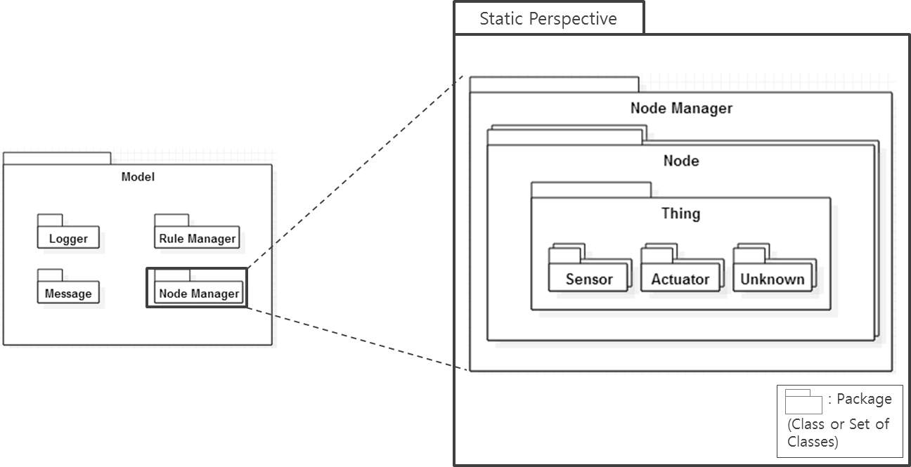
Figure 13. Static Perspective of NodeManager

NodeManager는 여러 개의 Node Instance를 생성/관리하고, Node들은 여러 개의 Thing Instance를 생성/관리한다. Thing은 Sensor나 Actuator 혹은 Unknown으로 구성되어 있다.
NodeManager는 현재 연결되어 있는 SA Node의 Instance 쉽게 추가/삭제하면서, 새로운 SA Node의 추가/삭제에 대한 쉬운 확장성을 제공한다. 또한, Node는 현재 연결되어있는 Thing들에 대한 Instance들을 추가/삭제하여 관리함으로써 새로운 Sensor나 Actuator들에 대한 쉬운 확장성을 제공한다.

Dynamic Perspective
NodeManager에 연관된 Dynamic Perspective의 전체 그림은 6.1.1의 Dynamic view of overall system을 참고하면 된다.
여기서는 NodeManager의 가장 중요한 Role중인 registerNode와 addNode에 대해서 Communication Diagram을 이용하여 자세하게 설명한다.

Communication Diagram of registerNode
사용자는 Discover가 된 Node들에 대해서 등록을 요청한다. Discover는 6.4.2의 Communication Manager의 Dynamic View를 참고한다. NodeManager는 사용자로부터 요청받은 Node에 대해서 SA Node에 등록을 요청하고 인증을 받는다. SA Node에 등록을 요청할 때, 사용자는 SA Node에 물리적으로 Printed되어있는 Label의 SerialNumber를 입력하고, SA Node는 이 SerialNumber가 Factory에서 설정된 Serial과 맞는지 비교하여 사용자의 등록을 허가한다. Node 등록시 사용되는 Security에 대한 내용은 6.6.2 Secure communicate between IoTMS and SA-Node에서 자세히 다룬다.

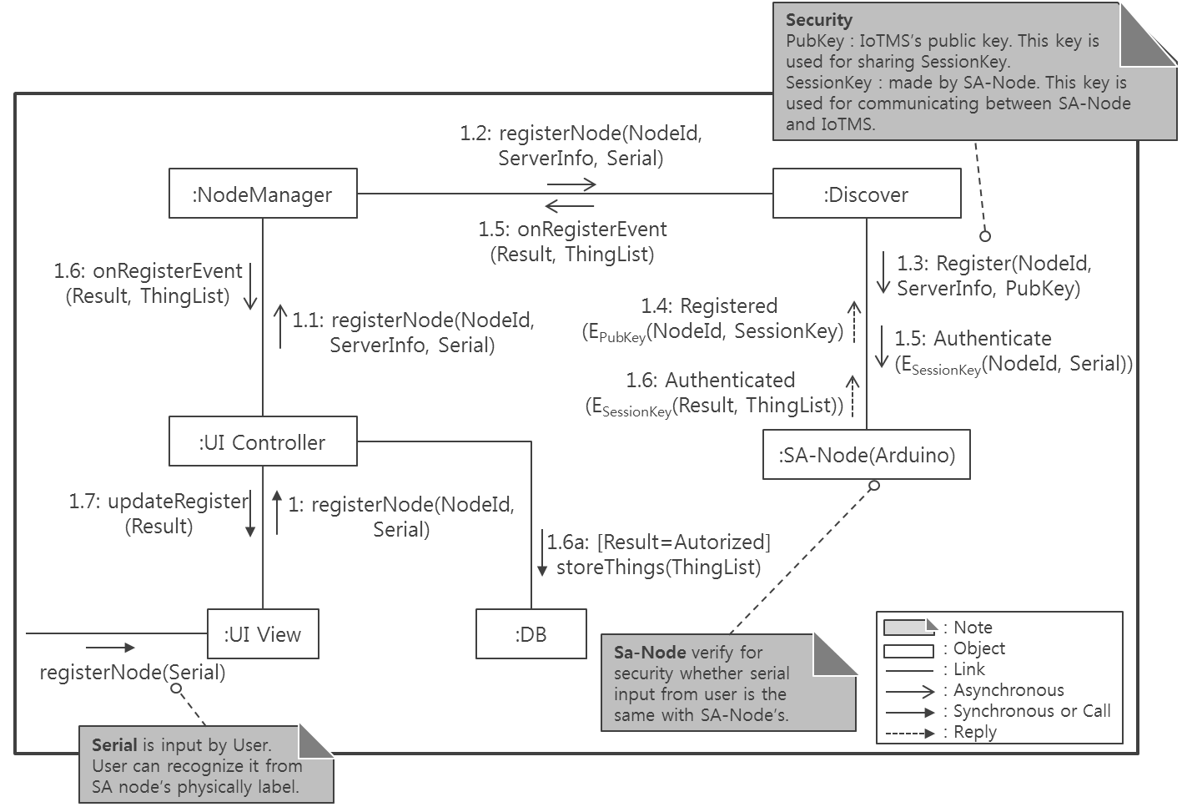
Figure 14. Communication Diagram: registerNode (Dynamic Perspective)

Communication Diagram of addNode
정상적으로 Node가 등록되면, NodeManager는 Node를 생성하고, Node는 Thing들을 생성한다. SA Node가 어떤 Thing들을 가지고 있는지는 Discover할 때 UI에서 저장해 놓은 DB를 query해서 Thing들을 생성한다. Node가 Thing들을 생성할 때에는 ThingFactory에 생성을 요청한다. Thing들은 Sensor, Actuator, Unknown으로 구분이 되어야 하고, 또한 SA Node로부터 올라오는 Thing의 정보들도 넣어 주어야 하기 때문에, Node의 Create에 대한 복잡도를 줄이기 위해 생성을 해주는 Factory를 따로 두었다. 아래 그림은 NodeManager가 Node를 추가하고, Node가 Thing들을 추가하는 Communication Diagram이다.

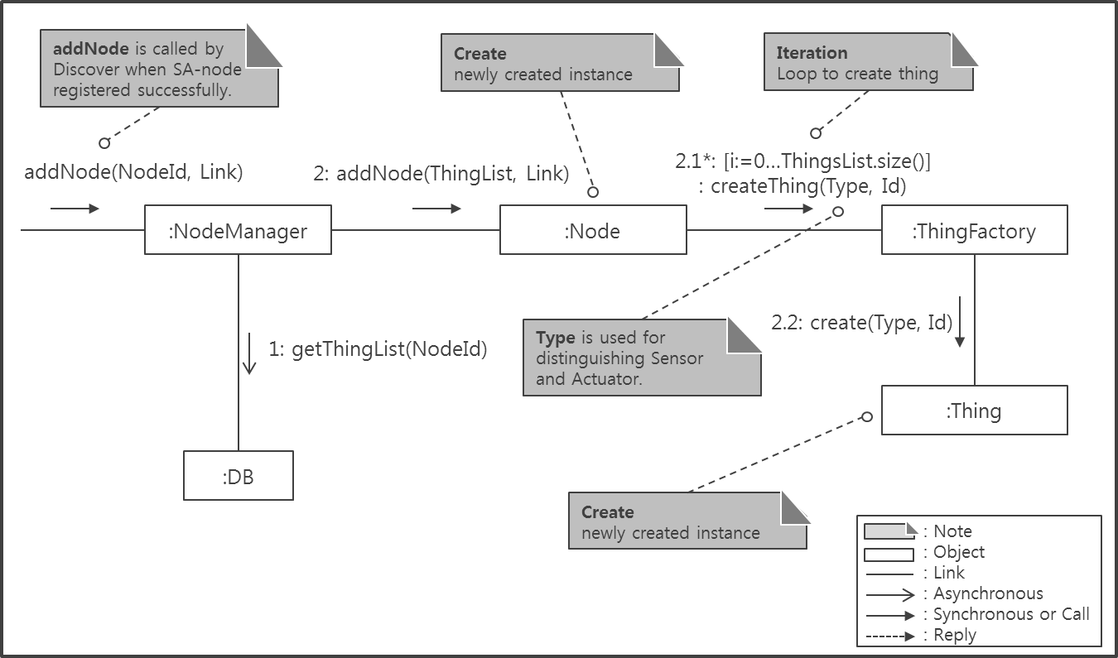
Figure 15. Communication Diagram: addNode (Dynamic Perspective)

Detailed Design
Static View와 Dynamic View를 고려하여 작성된 Generalization Style의 Module View는 다음과 같다.

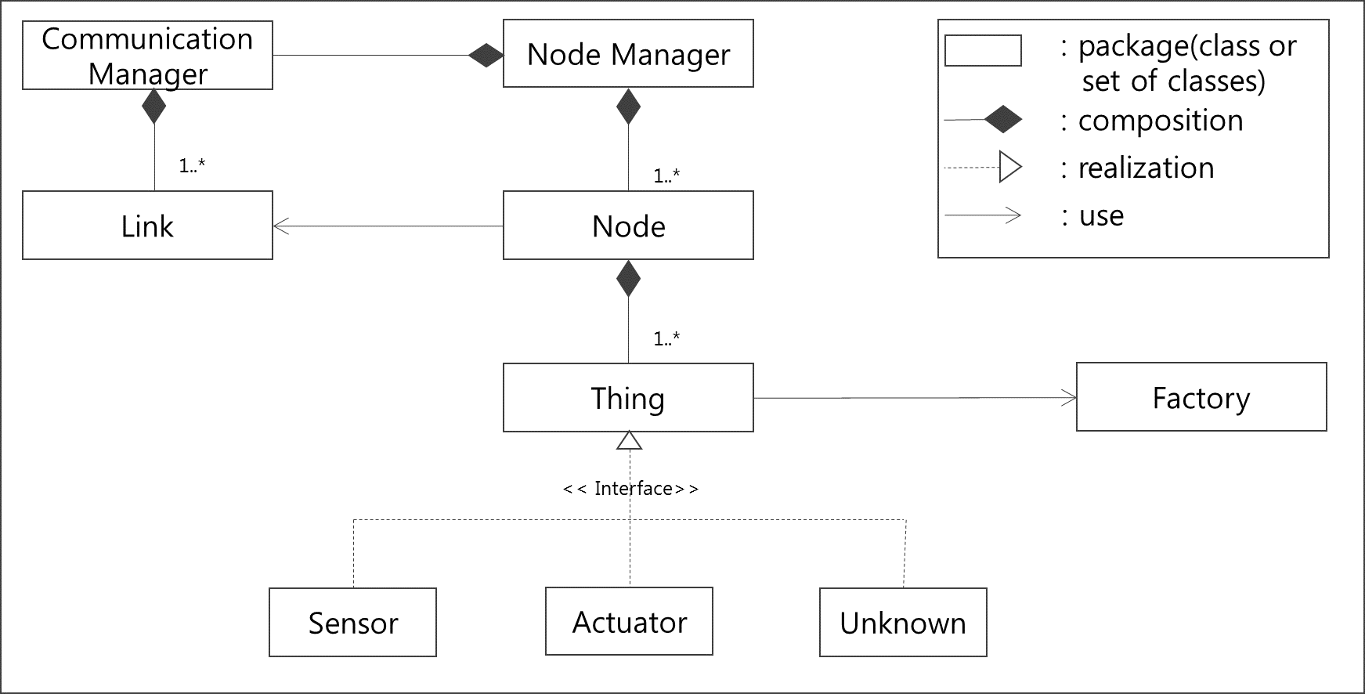
Figure 16. Module view of Generalization Style

NodeManager는 Communication Manager와 통신을 하며, CommunicationManager는 Node가 생성되었을 경우 연결객체인 Link를 생성하여 Node에게 넘겨준다. 이는 각 객체들의 SRP를 만족시키기 위해서 Design하였다.
또한, Thing의 생성은 Factory를 이용하여 생성하도록 하여 Node가 Thing을 어떤 객체를 생성할지 알지 않아도 되도록 하였다.
NodeManager는 IoTMS에서 중요한 Package중 하나이기 때문에, 상세한 설계를 포함한다. 위의 Generalization Style의 Model View와 Communication Diagram을 기반으로 Class Diagram을 아래와 같이 도출하였다.

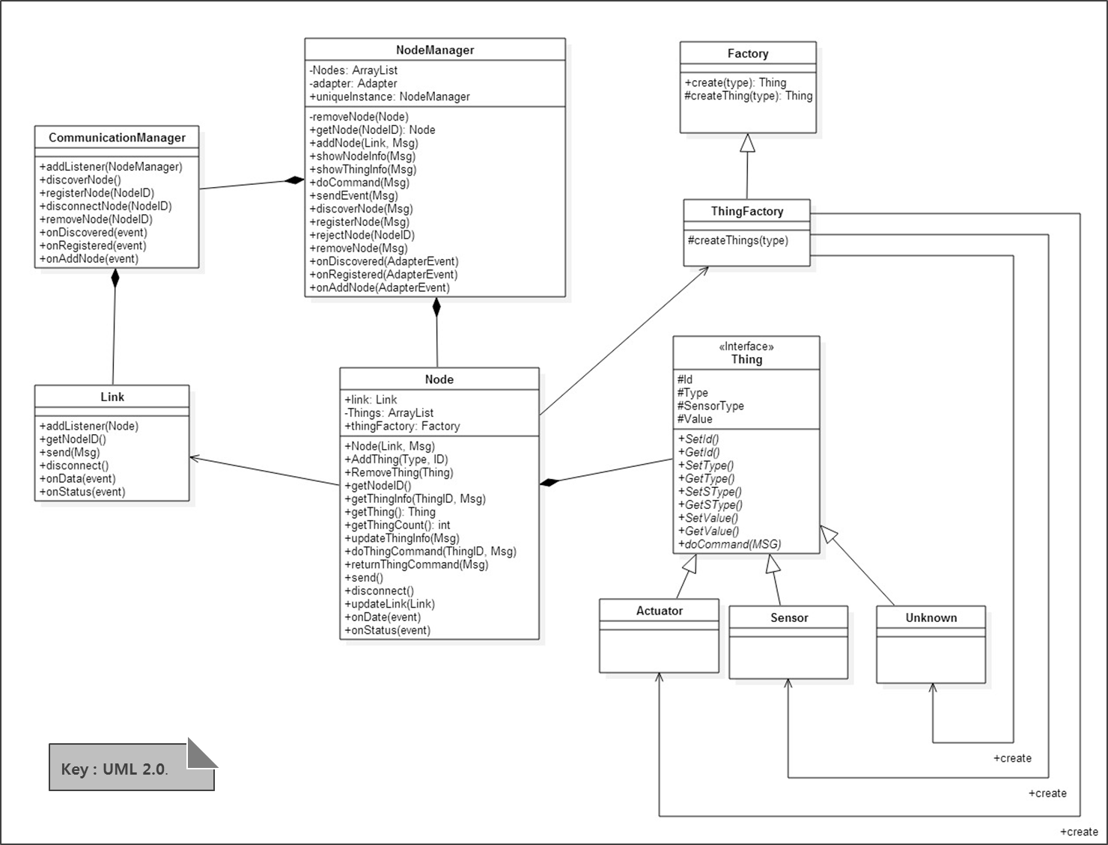
Figure 17. Class Diagram of NodeManager

Design Rationale

Using Abstraction of Things
NodeManager에서는 쉬운 Node의 Add/Remove를 위해 Node들을 필요할 때 생성한다.
Instance를 생성하는 객체가 두 가지가 존재한다. 그 중 하나는 NodeManager가 Node를 생성하는 것이고, 다른 하나는 Node가 Thing들을 생성하는 것이다. 이것은 Real-world에서 Node와 Thing들을 쉽게 Add/Remove하는 것을 지원하기 위함이다. 그래서 초기의 Design은 다음과 같았다.

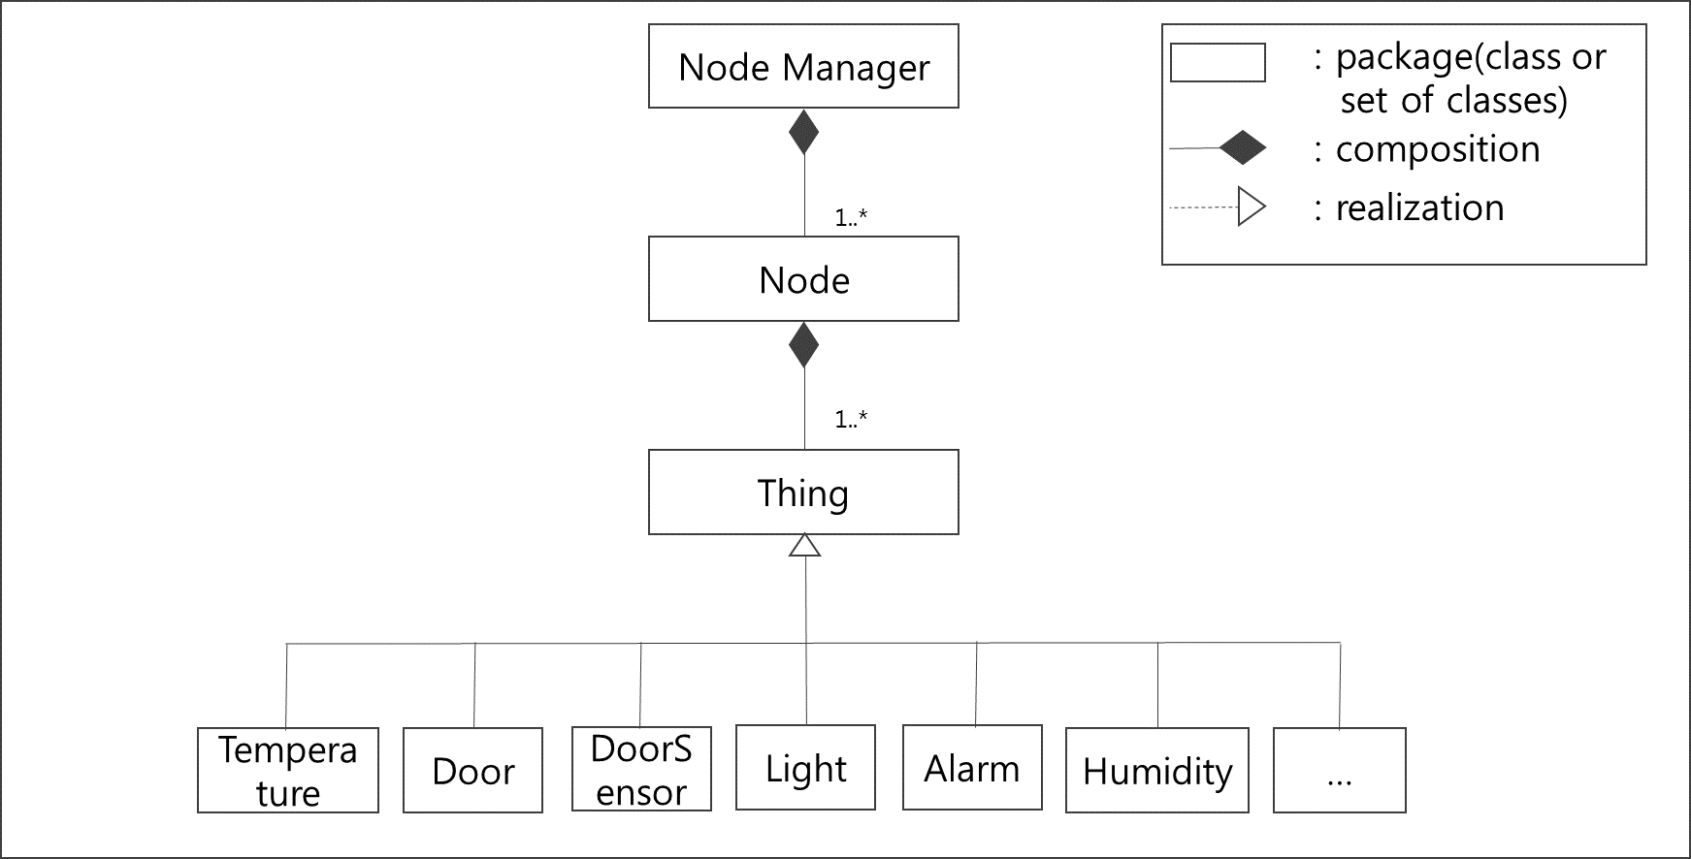
Figure 18. Initial Design of NodeManager (Static Perspective)

하지만, Pre-defined 되어있지 않은 Sensor나 Actuator (e.g. MailBox)가 달린 Node가 연결된다면, 이 프로그램에서는 Thing 객체를 수정해서 MailBox를 추가하여야 한다. 그렇기 때문에, Thing들을 Sensor와 Actuator 그리고, Unknown으로 일반화 시켜서 재구성하였다. 일반화 시킨 Design은 다음과 같다.

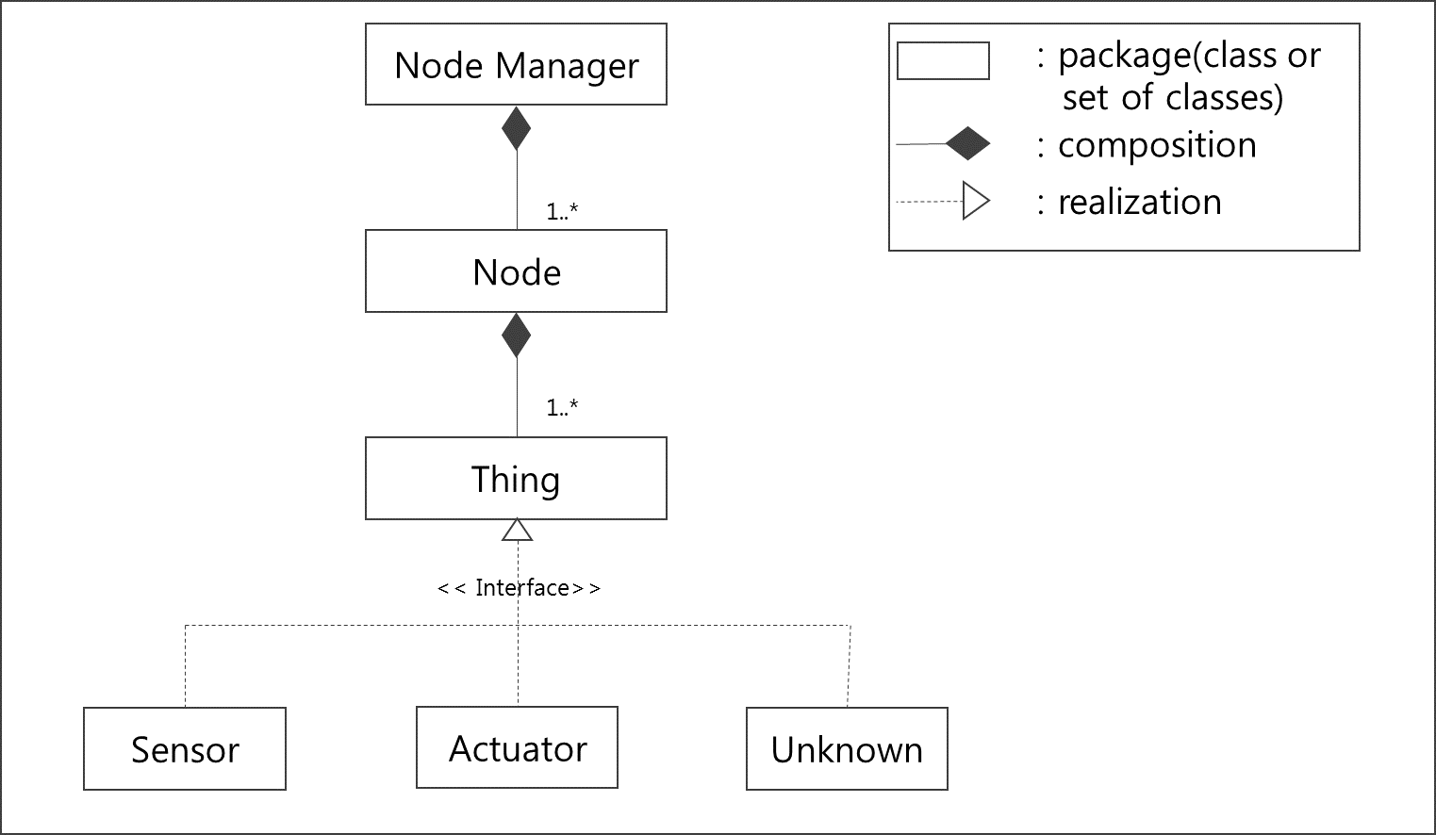
Figure 19. More Generalization Style of NodeManager(Static Perspective)

이 방식이 Scalability관점에서 이전 초기 Design에 비해 좋고, Thing의 Type이 많은 경우에는 만들어야 하는 객체의 개수를 줄일 수 있는 이점이 있다. 하지만, Sensor와 Actuator와 각각 다른 동작들이 있기 때문에 Node가 Thing을 생성하고 사용할 때 Thing이 Sensor인지 Actuator인지 혹은 Unknown인지 알아야만 하는 불편함이 있다. 예를 들어, Sensor는 값에 대한 정보를 읽어오는 동작은 하지만, On/Off나, Open/Close와 같은 Action은 실행할 수 없다. 마찬가지로 Actuator는 Action에 대한 동작은 할 수 있지만, 값에 대한 정보는 가지고 있지 않다. Sensor/Actuator/Unknown에 대한 다른 동작들은 다음과 같이 정리할 수 있다.

Type | Value | Action
Sensor | Available | Not Available
Actuator | Not Available | Available
Unknown | Available | Available
Table 25. Distinguishing Operation of Things

이런 불편함을 해결하기 위해, Thing들의 각기 다른 동작들을 최대한 보장하고 Node에 Dependency를 줄이기 위해 Factory를 따로 만들었다. Factory는 Thing들을 Sensor, Actuator, Unknown으로 구분하여 생성하고 생성된 객체를 Node에 전달해 준다. Node는 Thing들의 Type과 관계없이 모두 동일하게 Thing으로 사용할 수 있다.
이렇게 만들어진 Design은 6.2.1.3의 Detailed Design에 설명되어 있다.

Design Decision | Sensor/Actuator에 대한 추상화 및 Factory Method사용
Reason | 새로운 Type의 Thing에 대해서 대응이 어려움.  Node와의 Dependency를 줄이기 위해  3가지의 Thing Type으로 모든 Type의 센서 대응
Promoted Quality Attribute | Scalability
Trade Off | 복잡도 증가

Using Serial Number
IoTMS는 집에 있는 여러 가지 센서나 Actuator들을 Control하기 때문에, 높은 보안이 요구된다. IoTMS에서는 여러가지 보안 이슈가 있는데, 가장 큰 Concern중 하나인 다른 사용자가 User의 SA Node를 제어하는 부분을 방어하기 위해, IoTMS에서는 Node를 등록할 때 Serial Number를 사용한다.
Serial Number는 물리적으로 SA-Node에 프린트 되어있으며, 사용자가 SA-Node를 등록할 시에 프린트되어있는 Serial Number를 입력하여 Node를 등록한다. SA-Node는 Serial이 일치했을 경우에만 등록을 허가하여 동작하게 된다.

Design Decision | Using Serial Number
Reason | 다른 사용자가 User의 SA Node를 제어하는 부분을 방어하기 위해, IoTMS에서는 Node를 등록할 때 Serial Number를 사용
Promoted Quality Attribute | Security
Trade Off | SA Node와의 커뮤니케이션 복잡도 증가  사용자가 S/N을 확인하는 Step 추가

Using ThingList
NodeManager에서 Node를 추가할 때에 Node는 Thing들을 생성한다. Thing들은 ThingList로 묶여서 SA Node로부터 전달된다. 이 방식은 다음과 같은 장점이 있다.

Design Decision | SA Node로부터 전달받은 ThingList 사용
Reason | 지원하는 Thing들에 대한 의존성이 SA Node에 있어 새로운 Thing의 추가나, 다양한 Thing들을 지원하는 Node에도 코드의 추가나 수정없이 적용이 가능하다
Promoted Quality Attribute | Scalability
Trade Off | SA Node와의 커뮤니케이션 복잡도 증가

Related quality attributes
NodeManager의 설계는 Quality Attributes 중 Scalability를 만족한다.

ID | QA Type | Description
QA-03 | Scalability | IoT Management System is limited to 50 SA Nodes.
QA-05 | Security | IoT Management System allow only authorized user to access in secure way.
Table 26. Satisfied Quality Attribute of NodeManager

Architecture Design of RuleManager

Static Perspective

Dynamic Perspective

Design Rationale

Related quality attributes

Architecture Design of Logger

Static Perspective

Dynamic Perspective

Design Rationale

Related quality attributes

Architecture Design of Message

Static Perspective

Dynamic Perspective

Design Rationale

Related quality attributes

Architecture Design of UI and UI Controller

Static Perspective

Dynamic Perspective

Design Rationale

Related quality attributes

Architecture Design of Communication

Static Perspective
Functional decomposition
1) Multiple Communication Technology and Adapter

Physical / Link: Wifi, Bluetooth, Bluetooth Low Energy, IEEE802.15.4, Z-Wave, Mod bus, RS232, RS485
Network / Transport: TCP/IP, UDP, Bluetooth, Bluetooth Low Energy, Zigbee, Thread, Z-Wave
Application: Proprietary Protocol, Alljoyn, HTTP, HTTPS, Bluetooth, Bluetooth Low Energy, Zigbee, Z-Wave

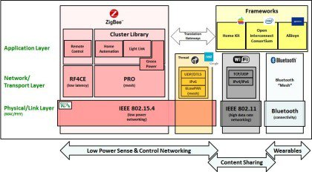
figure) protocol stack for IoTMS

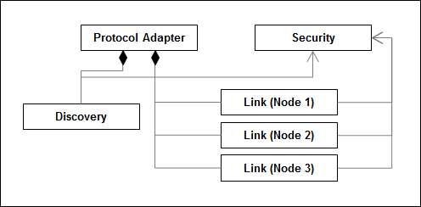
figure) Basic structure of IoTMS proprietary protocol package

Different types of communication technology (IoTMS proprietary protocol, bluetooth, and so on) share the same basic structure. Protocol Adapter has role to initiate other modules such as discovery and links. Discovery is responsible for finding and registering SA nodes. This can be replaced to standardized protocol such as UPnP and mDNS. It also will convert search result to JSON format which can be process on IoTMS internally. Link is responsible for the individual connection link between IoTMS and SA nodes. Each node in node manager will communicate with actual SA nodes using the handle of Link. Both discovery and link provides common interface such as discover, register, connect, disconnect, send, receive and some others.

Basically, IoTMS’s communication package provides means to communication with those protocols seamlessly. All of those protocols provides several common interfaces for discovery, registration, connection, transmission, and reception.

Discovery | discover
Discovery | register
Discovery | cancel
Link | connect
Link | disconnect
Link | send
Link | receiver

figure) list of common interfaces

Dynamic Perspective

1) Discovery and Registration

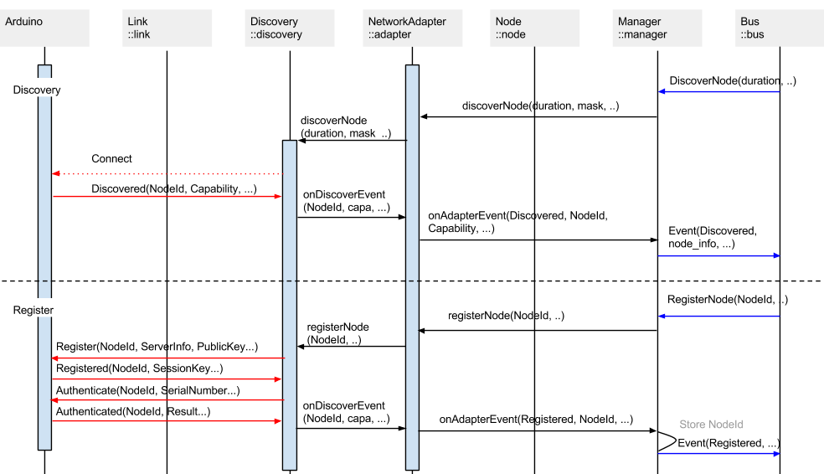
figure) sequence diagram for discovery

2) Connection, Authentication and Disconnection

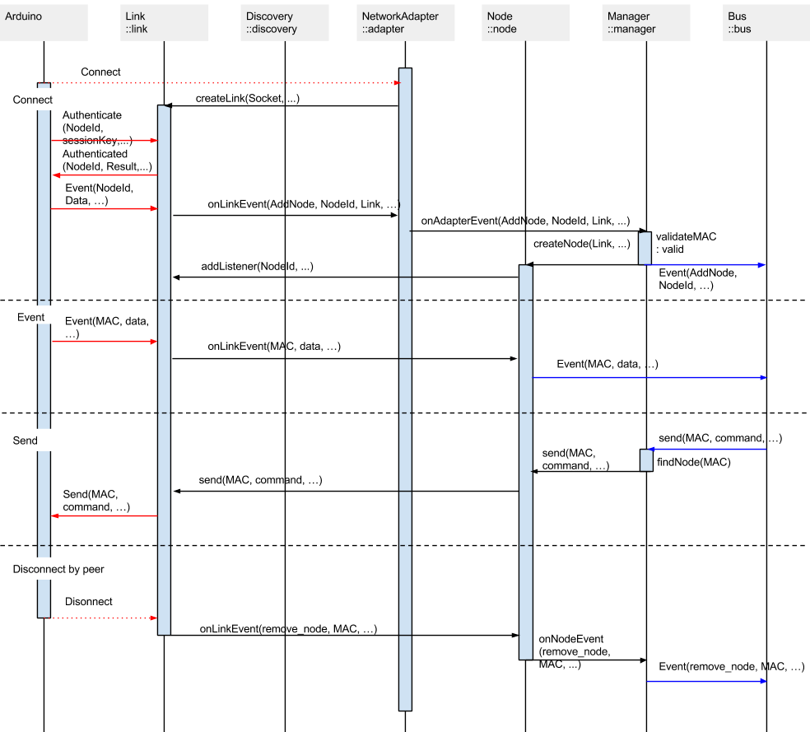
figure) sequence diagram for connection

Design Rationale

1) Different ways to support multiple connectivity technology

2) Protocol Design: Why JSON?

Basically, JSON data is human readable. It is easy to monitor the data interaction among packages internally. Therefore, this characteristics of JSON enhances the productivity as well. Also, the flexibility of JSON is one of benefits. In this system, there are numbers of different functional blocks, blocks for supporting different communication technologies such as bluetooth and zigbee and blocks for supporting different types of sensors and actuators. JSON can handle newly defined data easily by adding a pair of key and value.

Pros: Understandability, Extensibility
Cons: Performance, Data size,

3) Periodic Health Check

There’re number of different tactics for periodic health checking. For example,

- ping-echo
- heartbeat
- piggyback

The reason why we chose piggybacking is that there’s a periodic event which updating sensor data every 3 second. Therefore, there’s no need to transmit additional packets for heartbeat or ping-echo tactics.

4) authentication

The serial number labeled on SA node provides additional security because an attacker is not able to intercept the SA node without knowing the serial number physically labelled on the SA node. The only user who actually own the SA node can access and register to the node.

5) Unique node identification

mac address
uuid

6) blocking and nonblocking io

Related quality attributes

1) Availability

piggyback tatic

2) Modifiability (scalability)

provide interface for supporting different types of network protocols seemlessly
provide interface for supporting different types of discovery protocols seemlessly
support up to 50 SA nodes

3) Security

provide interface for supporting public/symmetric key library

4) Performance

piggyback tactic for avoiding periodic health check

Architecture Design of SA-Node

Static Perspective

Dynamic Perspective

Design Rationale

Related quality attributes

Security
IoTMS가 Home의 Sensor와 Actuator를 제어하는 System이므로, 안전한 통신이 설계에서 가장 중요한 QA중 하나이다. 그래서, IoTMS에서는 안전한 통신을 지원하기 위해 User와 User Interface간의 Secure Channel과 IoTMS와 SA-Node간의 Secure Channel을 지원한다. 또한, 다른 사용자의 Node제어를 예방하기 위해, SA-Node 등록 시 SA-Node에 Printed되어 있는 Serial Number를 입력하여 등록할 수 있도록 한다. 이것은 6.6.2 Secure communicate between IoTMS and SA-Node에서 확인 할 수 있다.

Secure communicate between User and User Interface
IoTMS는 집안에 있는 Sensor들을 제어하기 때문에, Security에 굉장히 민감한 프로젝트이다. 또한, User의 편의를 위해 Internet을 통해 이것들을 제어하기 때문에, IoTMS와 User와의 보안이 중요하다. IoTMS는 가장 보편적인 인증방식인 Authentication, Authorization, Accounting을 기반으로 설계되었다.

Secure communicate between IoTMS and SA-Node
IoTMS와 SA-Node의 안전한 통신을 위해 통신간의 암호화 통신을 지원한다. 안전한 통신을 사용하는 목적은 다른 사용자가 SA Node를 임의로 사용하거나 제어하는 것을 막고, SA Node의 정보가 유출되는 것을 방지하기 위함이다.
암호화 통신은 공개키 방식의 암호 알고리즘을 이용하여 Session Key를 공유한 뒤, 공유된 Session Key를 이용하여 대칭키 방식의 암호화 통신을 한다.
공개키 방식의 암호 알고리즘은 RSA를 사용하며, 대칭키 방식의 암호 알고리즘은 AES를 사용한다. Session Key는 Node가 등록될 때와 등록된 Node가 끊어졌다가 처음 접속 할 때 Key를 공유한다. 아래는 Discover와 Register시의 Sequence Diagram이다.

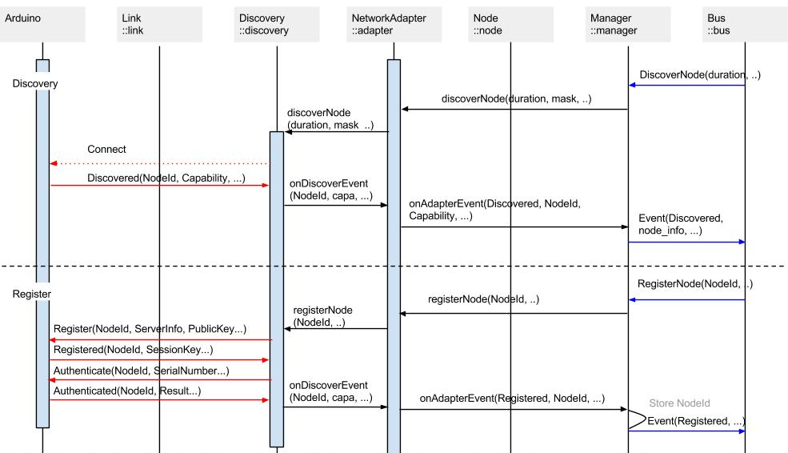
Figure 20. Sequence Diagram of discoverNode, registerNode

Node를 새로 등록 시에는 다른 사용자가 Node를 등록하지 못하도록SA-Node에 Printed되어있는 Label의 Serial Number를 입력하여 이 Serial Number가 일치하여야 등록할 수 있도록 하였다. 등록에서 필요한 암호화 통신의 자세한 내용은 아래와 같다.

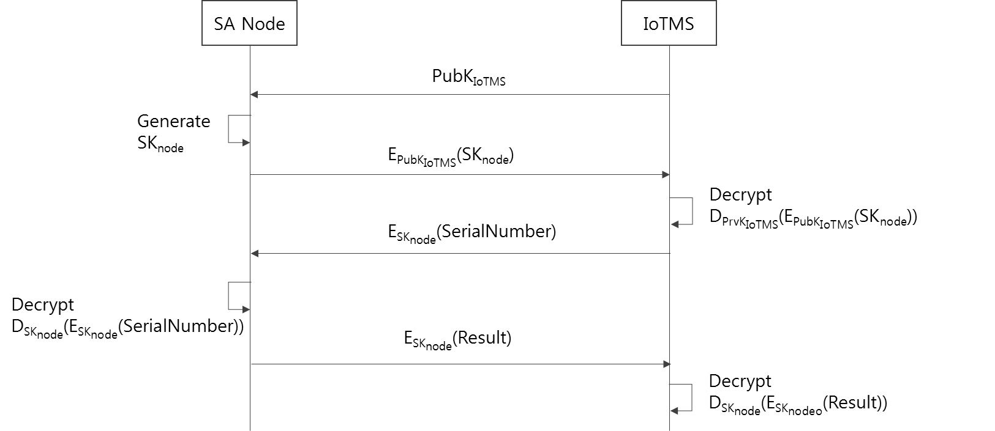
Figure 21. Crypto Protocol when IoTMS register SA Node

위 그림에 대한 각 notation에 대한 설명은 다음과 같다.
Notation | Description
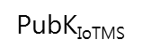 | Public Key of IoTMS. This key is used only when SA Node share its session key to IoTMS..
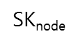 | Session Key generated by SA Node. After registered, IoTMS and SA Node should communicated with this Key.
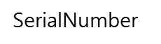 | Serial Number. This is pre-printed label on the SA Node physically.
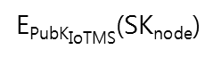 | It means to encrypt SK_{node}(Session Key) using by Public Key of IoTMS. In generally, it used RSA encryption algorithm.
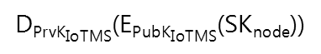 | It means to decrypt encryption data using by Private Key of IoTMS.
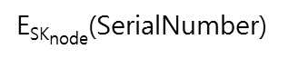 | It means to encrypt SerialNumber using by Session Key. In generally, it used AES encryption algorithm.
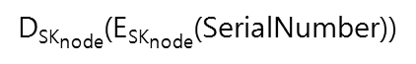 | It means to decrypt encryption data using by Session Key.

이후 Node가 재접속할 때에는 SA Node가 Connection을 시도하면서 SessionKey를 생성하여 SA Node에 저장되어있던 PublicKey로 암호화하여 SessionKey를 공유한다.

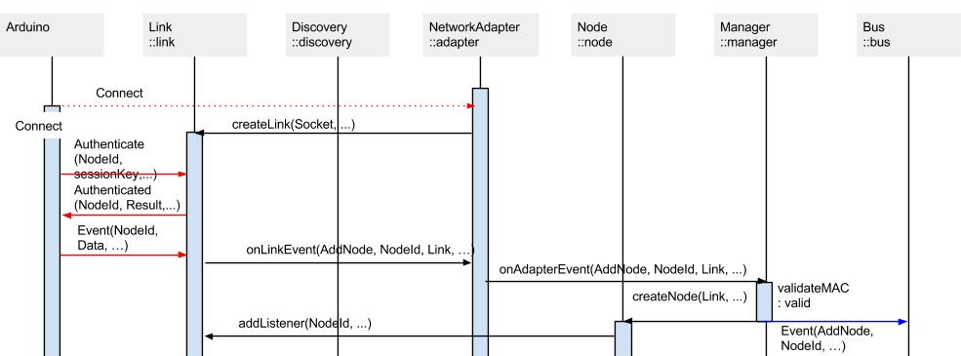
Figure 22. Sequence Diagram of Connect

Connect시의 암호화 관련 동작도 Register때와 유사하나, SA Node가 이미 PublicKey of IoTMS를 알고 있으므로, 해당 동작은 생략하고 바로 SessionKey를 생성하여 PublickKey로 암호화하여 IoTMS에 전송한다. Connect시 사용되는 암호화 관련 프로토콜은 아래와 같다.

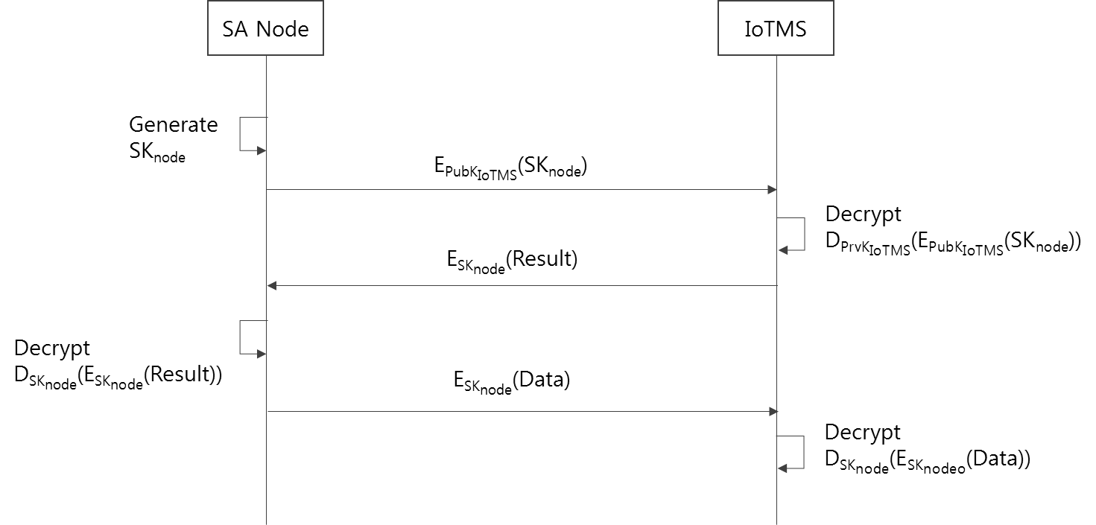
Figure 23. Sequence Diagram when SA Node connect to IoTMS

위 그림에 대한 각 notation에 대한 설명은 다음과 같다.
Notation | Description
 | Public Key of IoTMS. This key is used only when SA Node share its session key to IoTMS..
 | Session Key generated by SA Node. After registered, IoTMS and SA Node should communicated with this Key.
 | It means to encrypt SK_{node}(Session Key) using by Public Key of IoTMS. In generally, it used RSA encryption algorithm.
 | It means to decrypt encryption data using by Private Key of IoTMS.
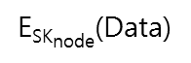 | It means to encrypt Data using by Session Key. In generally, it used AES encryption algorithm.
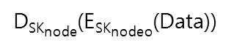 | It means to decrypt encryption Data using by Session Key.

이런 방식으로 항상 IoTMS와 SA-Node는 Secure한 상태의 Channel을 유지한다.
암호화 통신을 위해 IoTMS와 SA-Node는 정의된 Data Format을 사용해야하며, 그 규격은 아래와 같다.
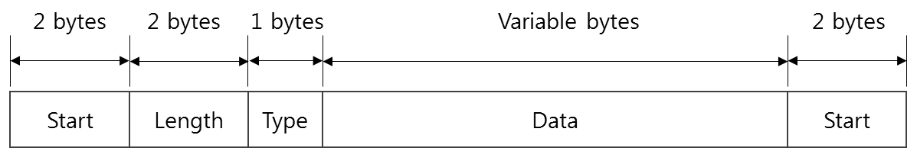
Figure 24. Data Format

Document Dictionary

Glossary
The glossaries in this document are described.
Glossaries | Description

Acronyms
The acronyms in this document are described.
Acronyms | Description

Index
문서 완료 후

